**HW7**

**7a: Setting Up an Amazon Redis Cluster**

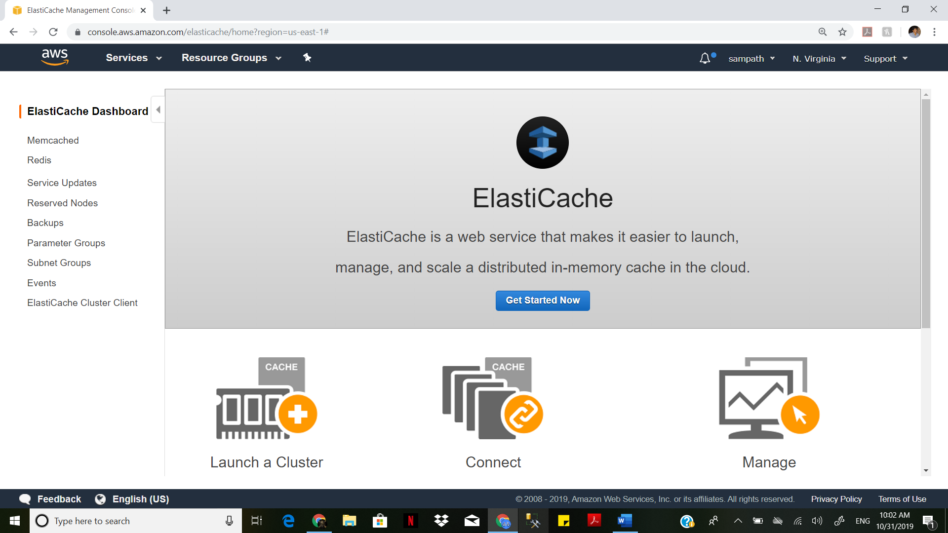

Open Amazon Management Console

Go to ElastiCache

Click on Get Started now

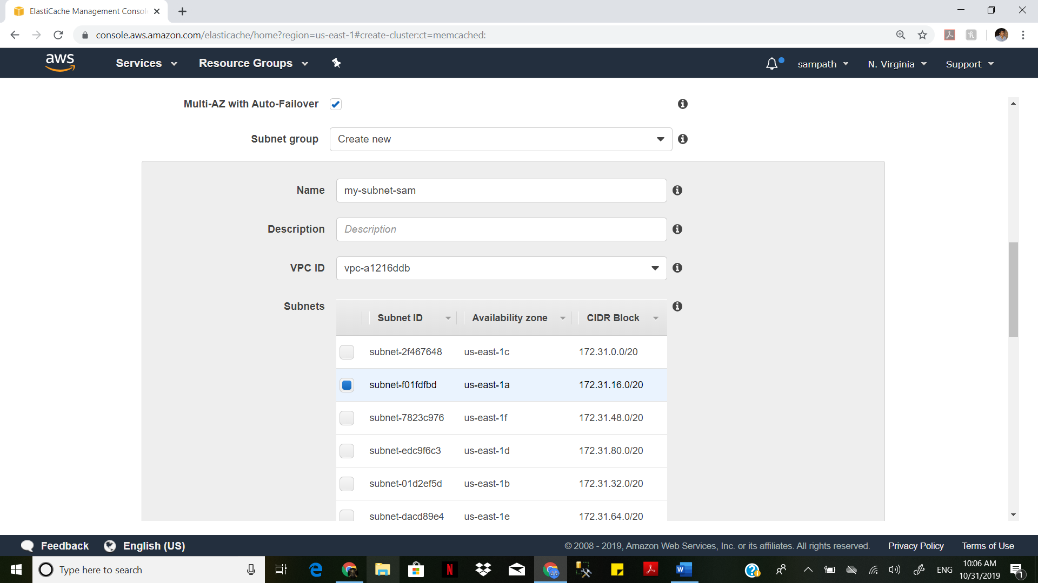

Select Redis Cluster, Select t2 as Node type Create a new subnet

Select the Subnet in your region

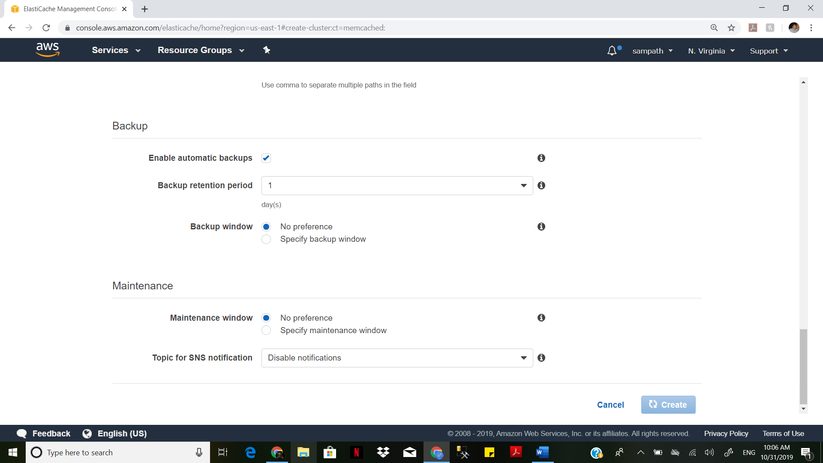

Then Create the Cluster Once Redis Cluster is Created. select the default security group or else create a new one. Then edit the inbound rules for your security group. Create a regular Ec2 Instance.

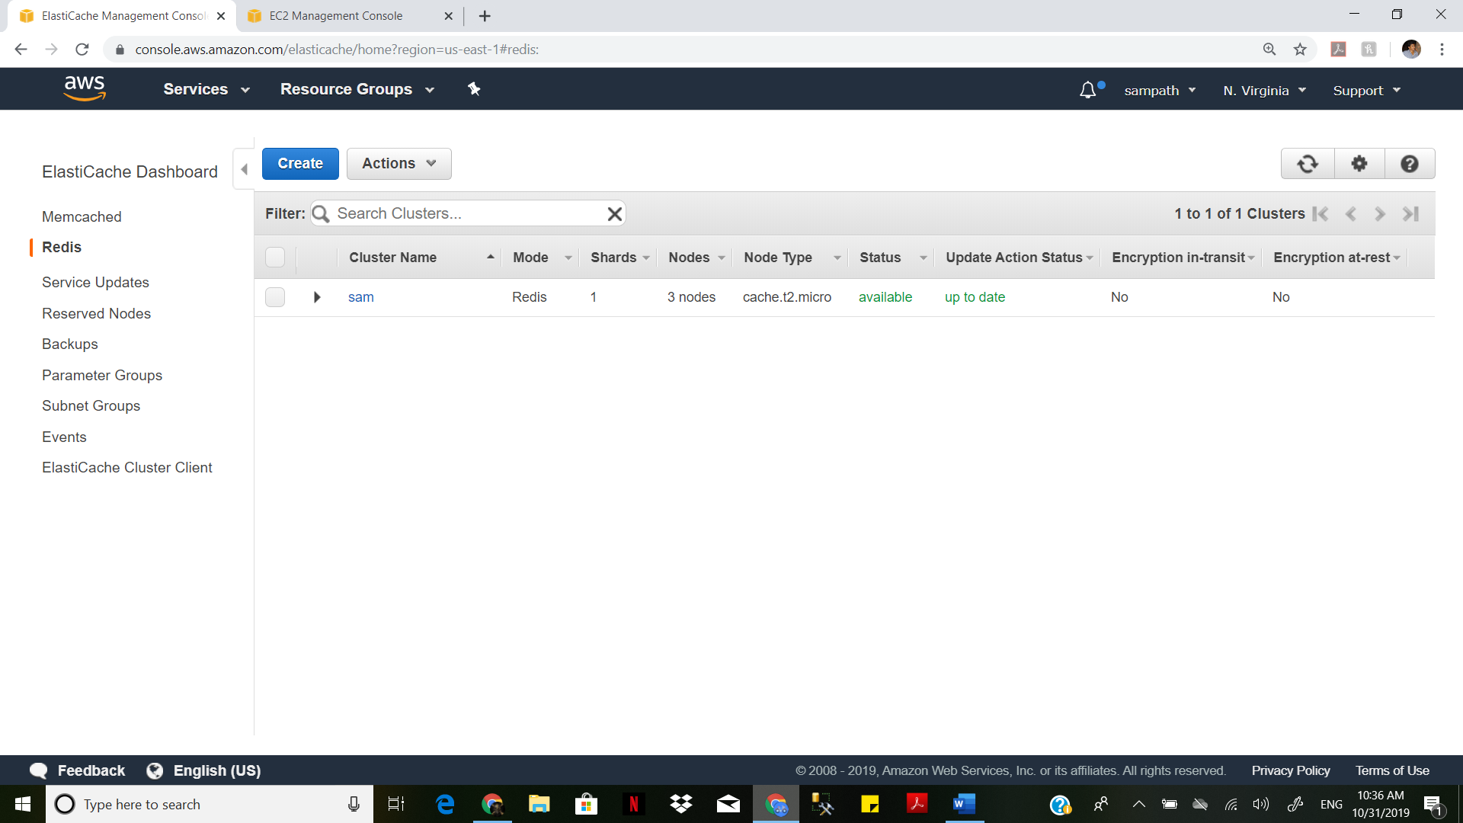

Connect to putty

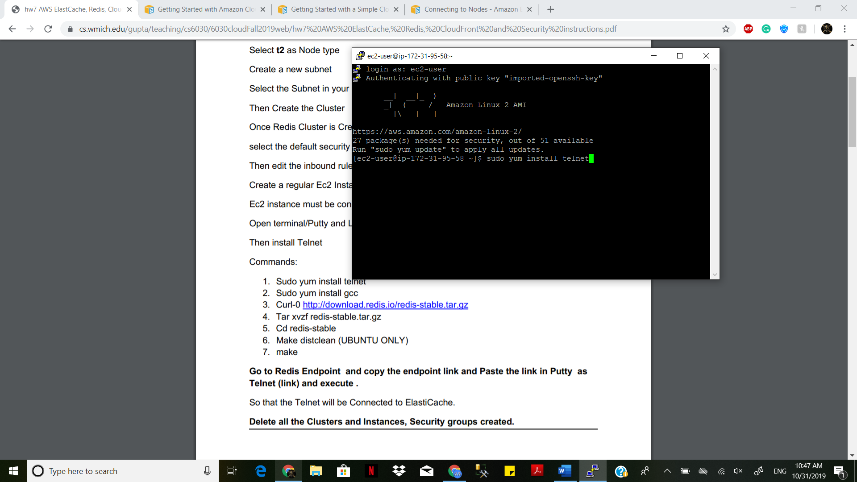

Ec2 instance must be connected to Redis Cluster. Open terminal/Putty and Login.

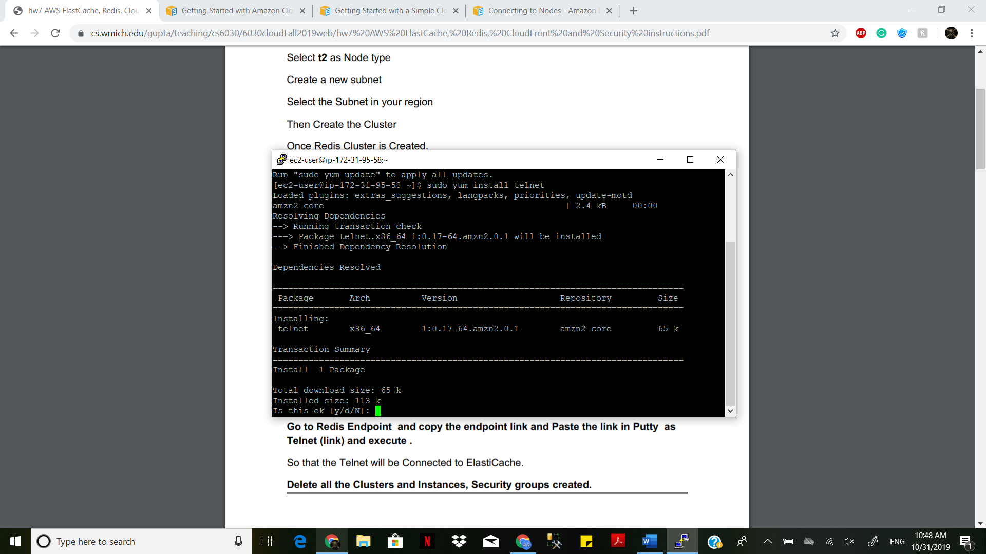

Then install Telnet

Sudo yum install telnet

Sudo yum install gcc

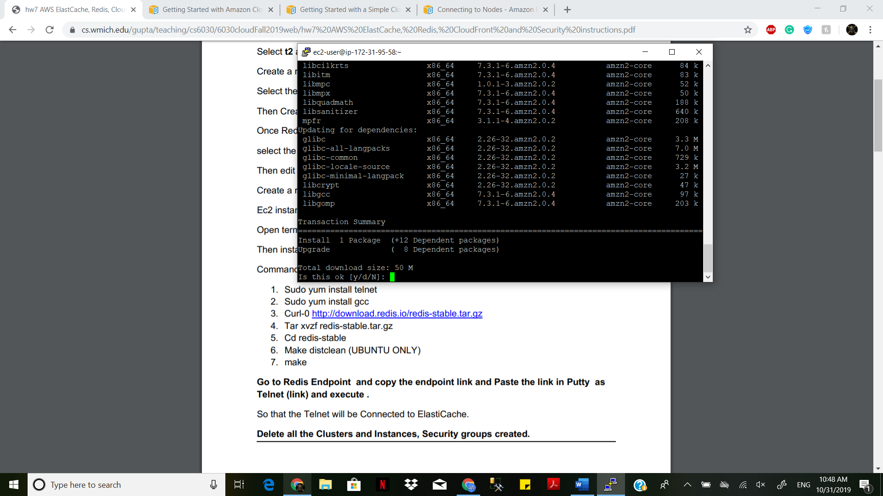

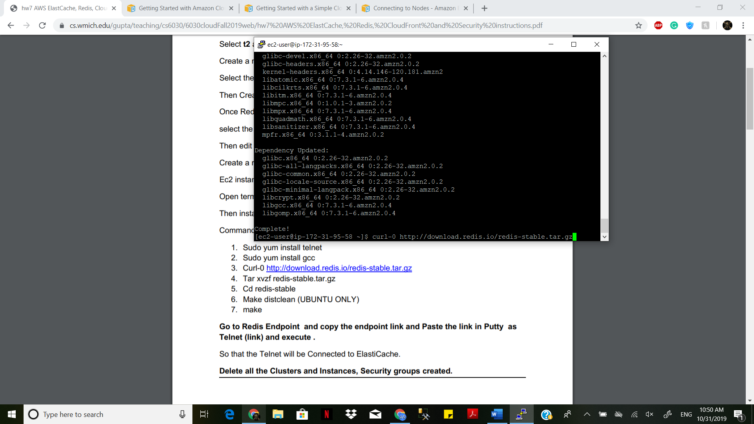

Curl-0 http://download.redis.io/redis-stable.tar.gz

Tar xvzf redis-stable.tar.gz

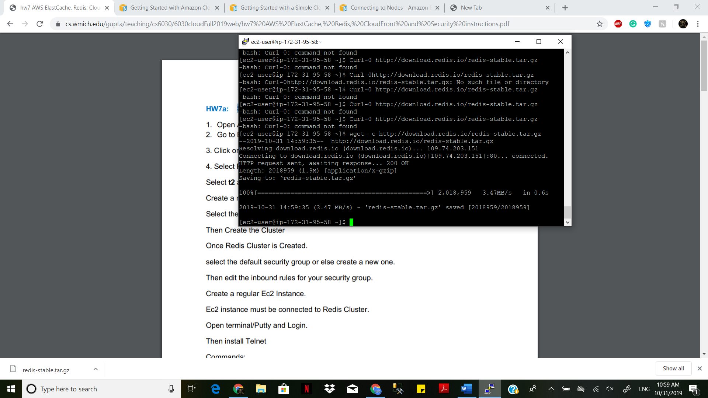

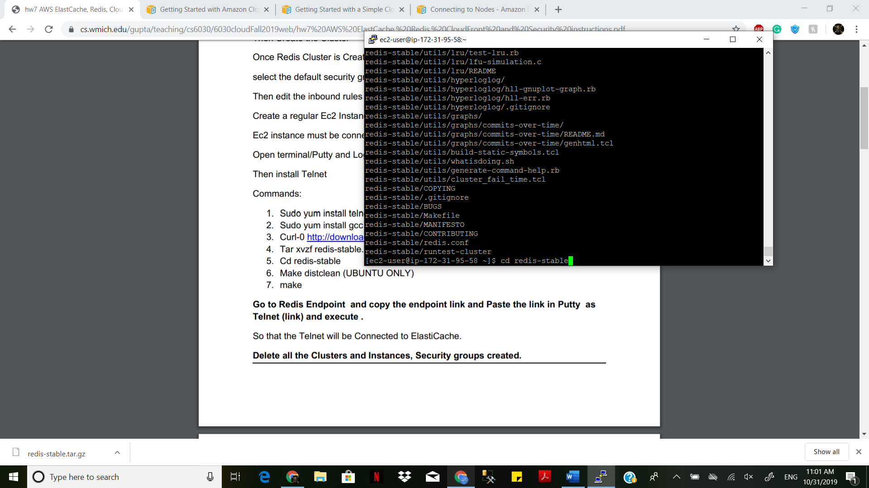

Go to Redis Endpoint and copy the endpoint link and Paste the link in Putty as Telnet (link) and execute. So that the Telnet will be Connected to ElastiCache

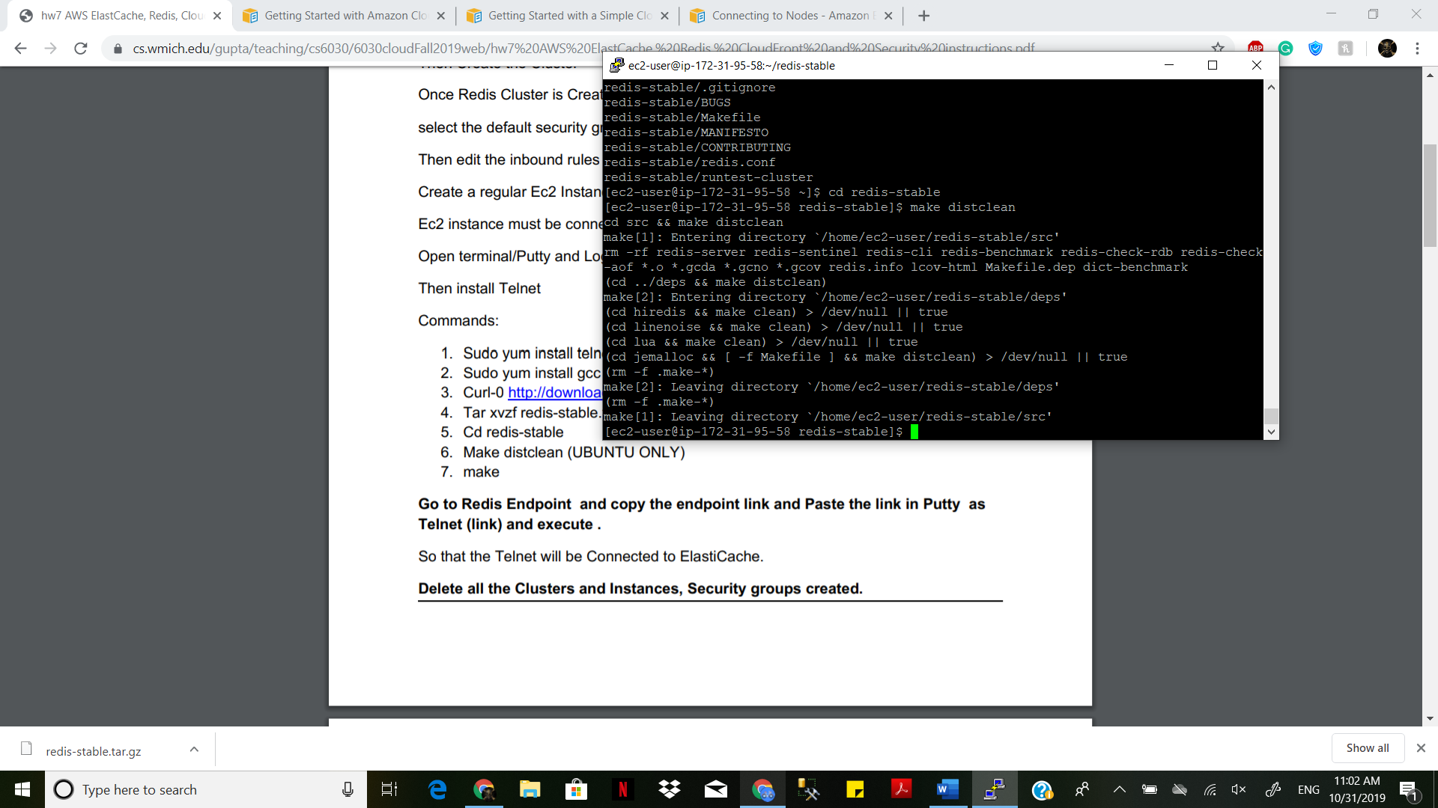

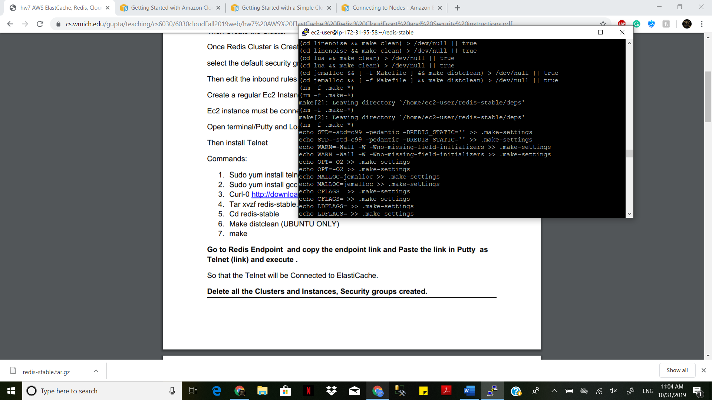

Delete all the Clusters and Instances, Security groups created.

**7B: AMAZON CLOUDFRONT**

Upload your content to Amazon S3 and grant object permissions

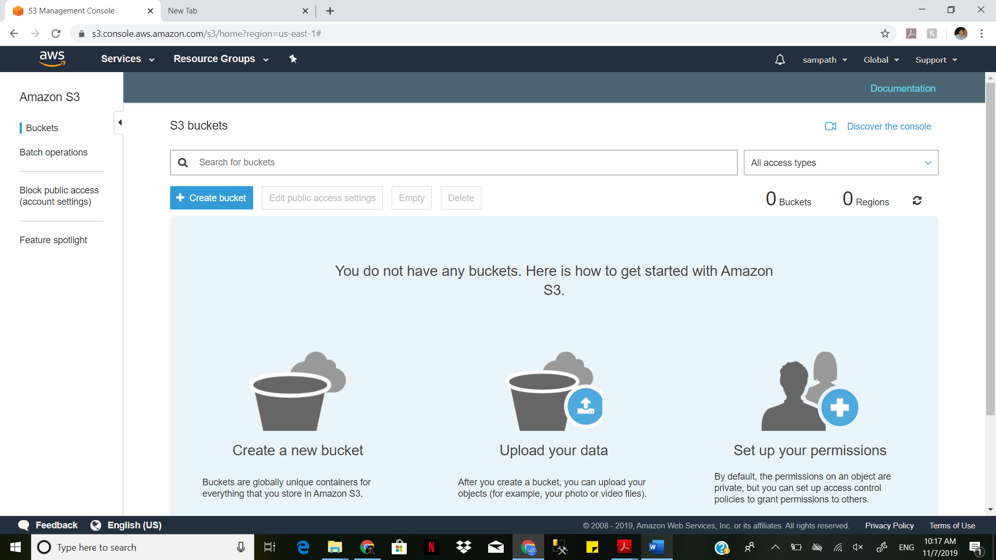

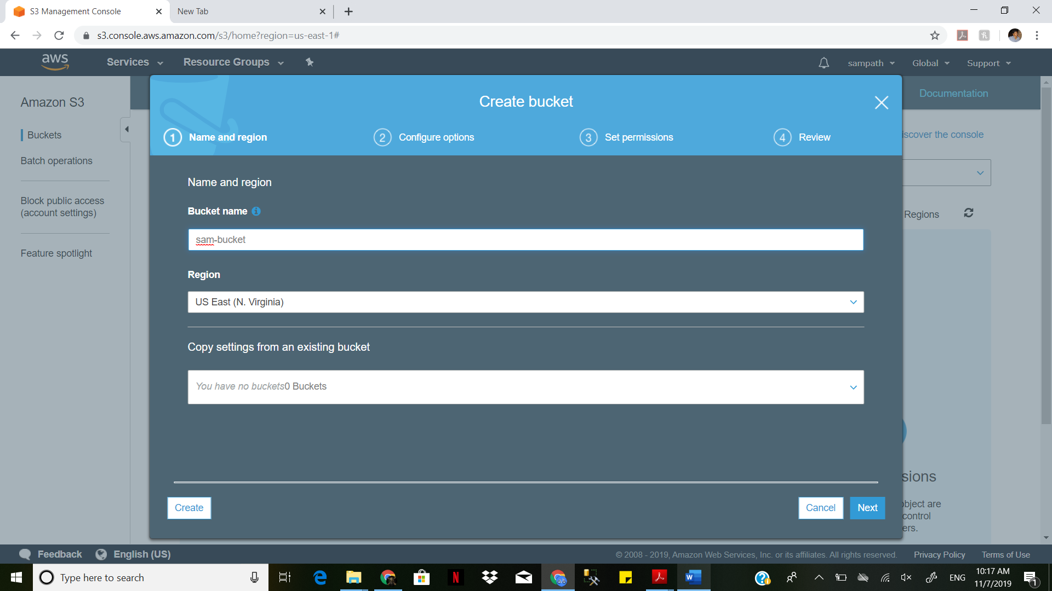

After the upload completes, you can navigate to the item by using its URL. Using previous tutorials, the URL would be something like: http://s3- myregion.amazonaws.com/example-aws-s3-bucket1/filename

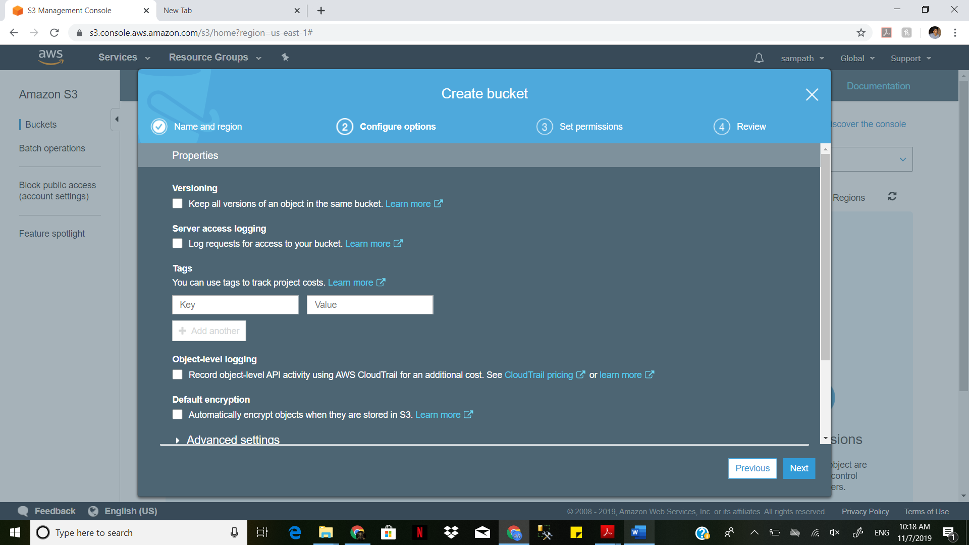

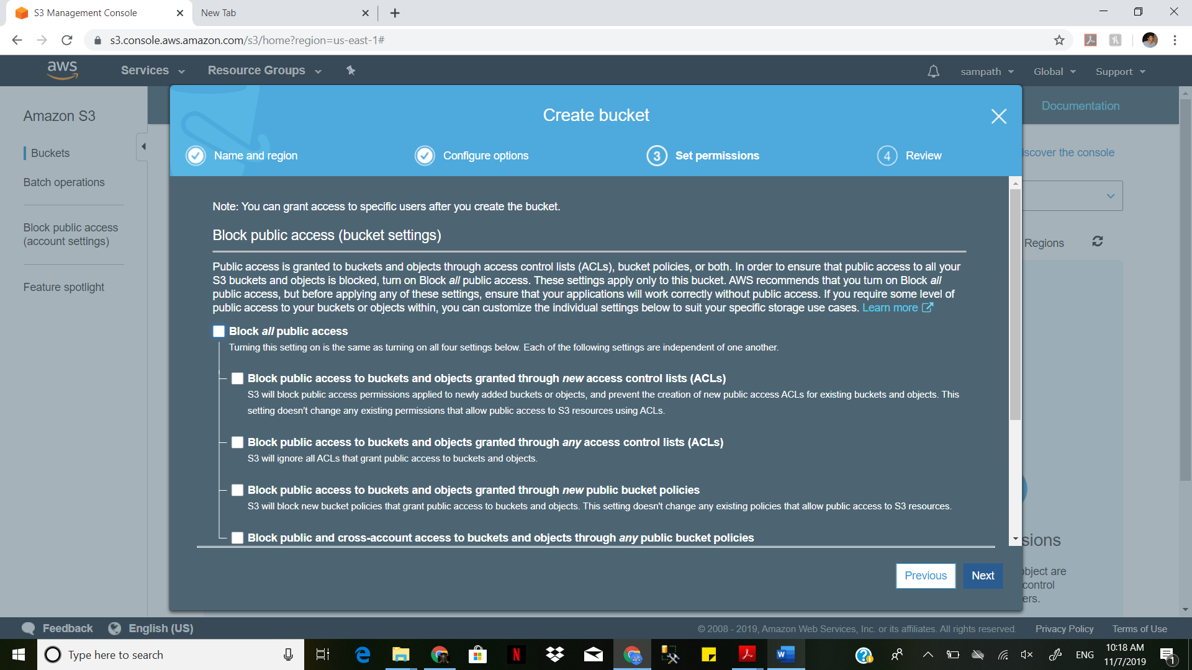

Use your Amazon S3 URL to verify that your content is publicly accessible, but remember that this is not the URL you'll use when you're ready to distribute your content with CloudFront.

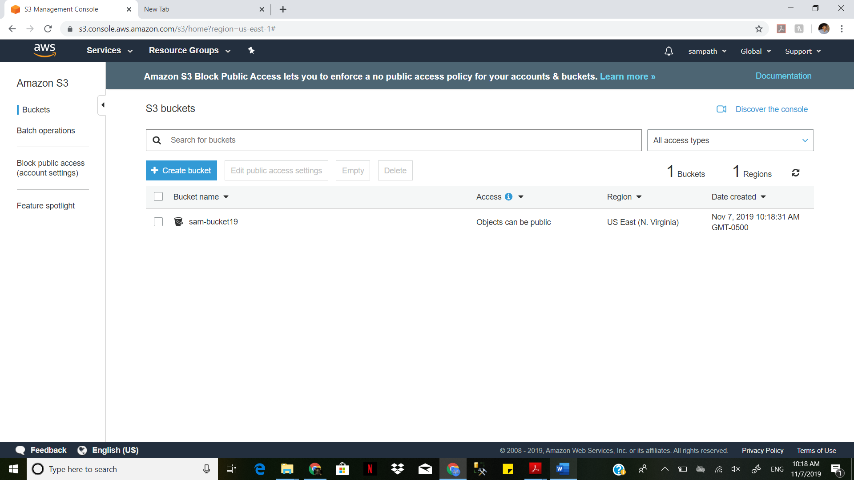

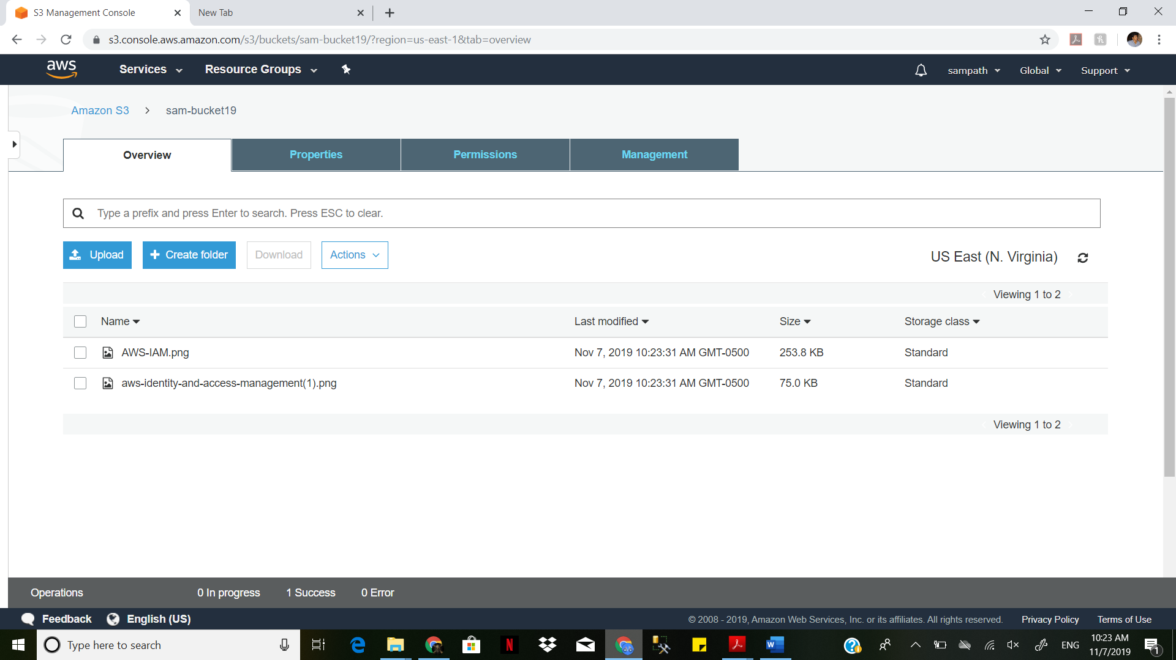

**Create a CloudFront distribution:**

Use Default Cache Behavior Settings and CloudFront will:

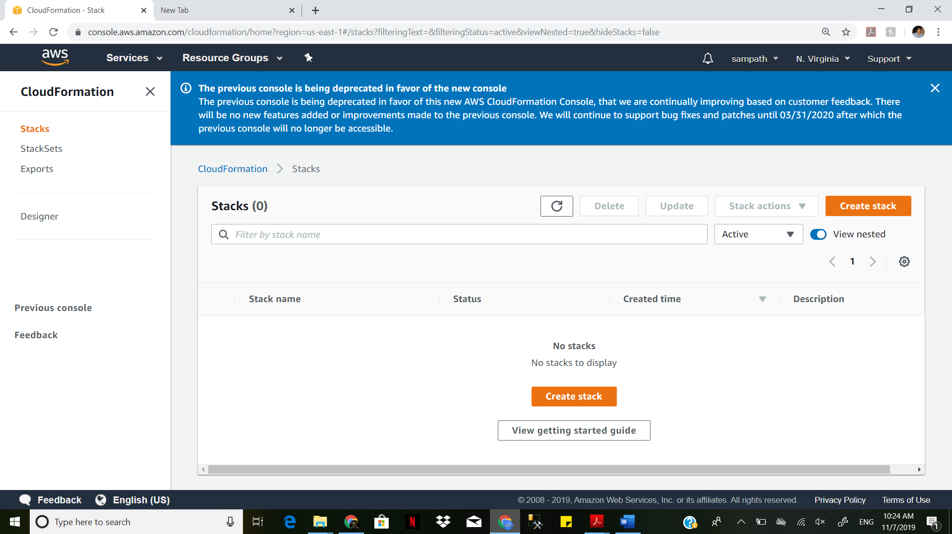

Forward all requests that use the CloudFront URL for your distribution (for example, http://d111111abcdef8.cloudfront.net/image.jpg) to the Amazon S3 bucket).

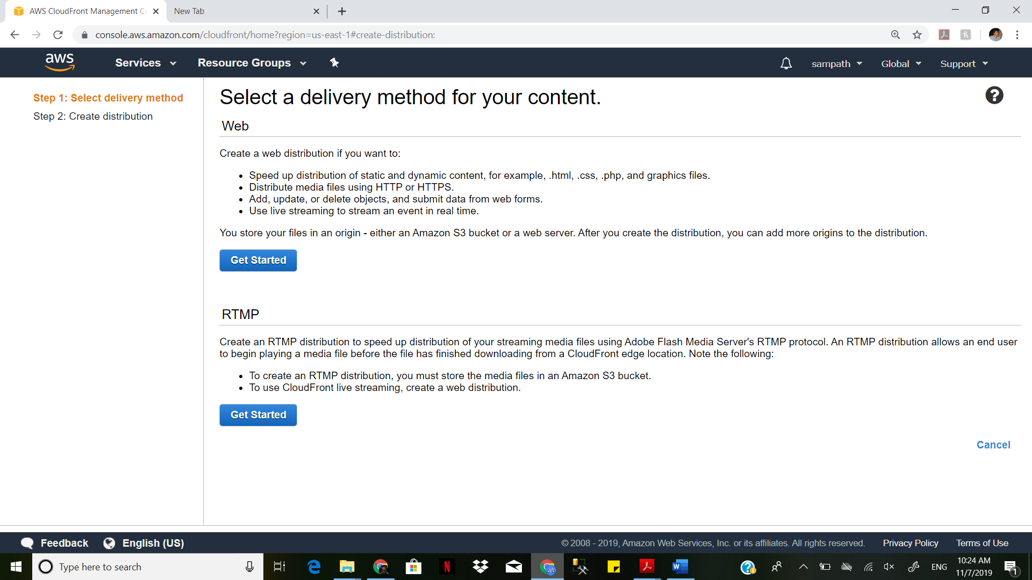

Allow end users to use either HTTP or HTTPS to access your objects.

Respond to requests for your objects.

Cache your objects at CloudFront edge locations for 24 hours

Forward only the default request headers to your origin and not cache your objects based on the values in the headers. Exclude cookies and query string parameters, if any, when forwarding requests for objects to your origin. (Amazon S3 doesn't process cookies and processes only a limited set of query string parameters.)

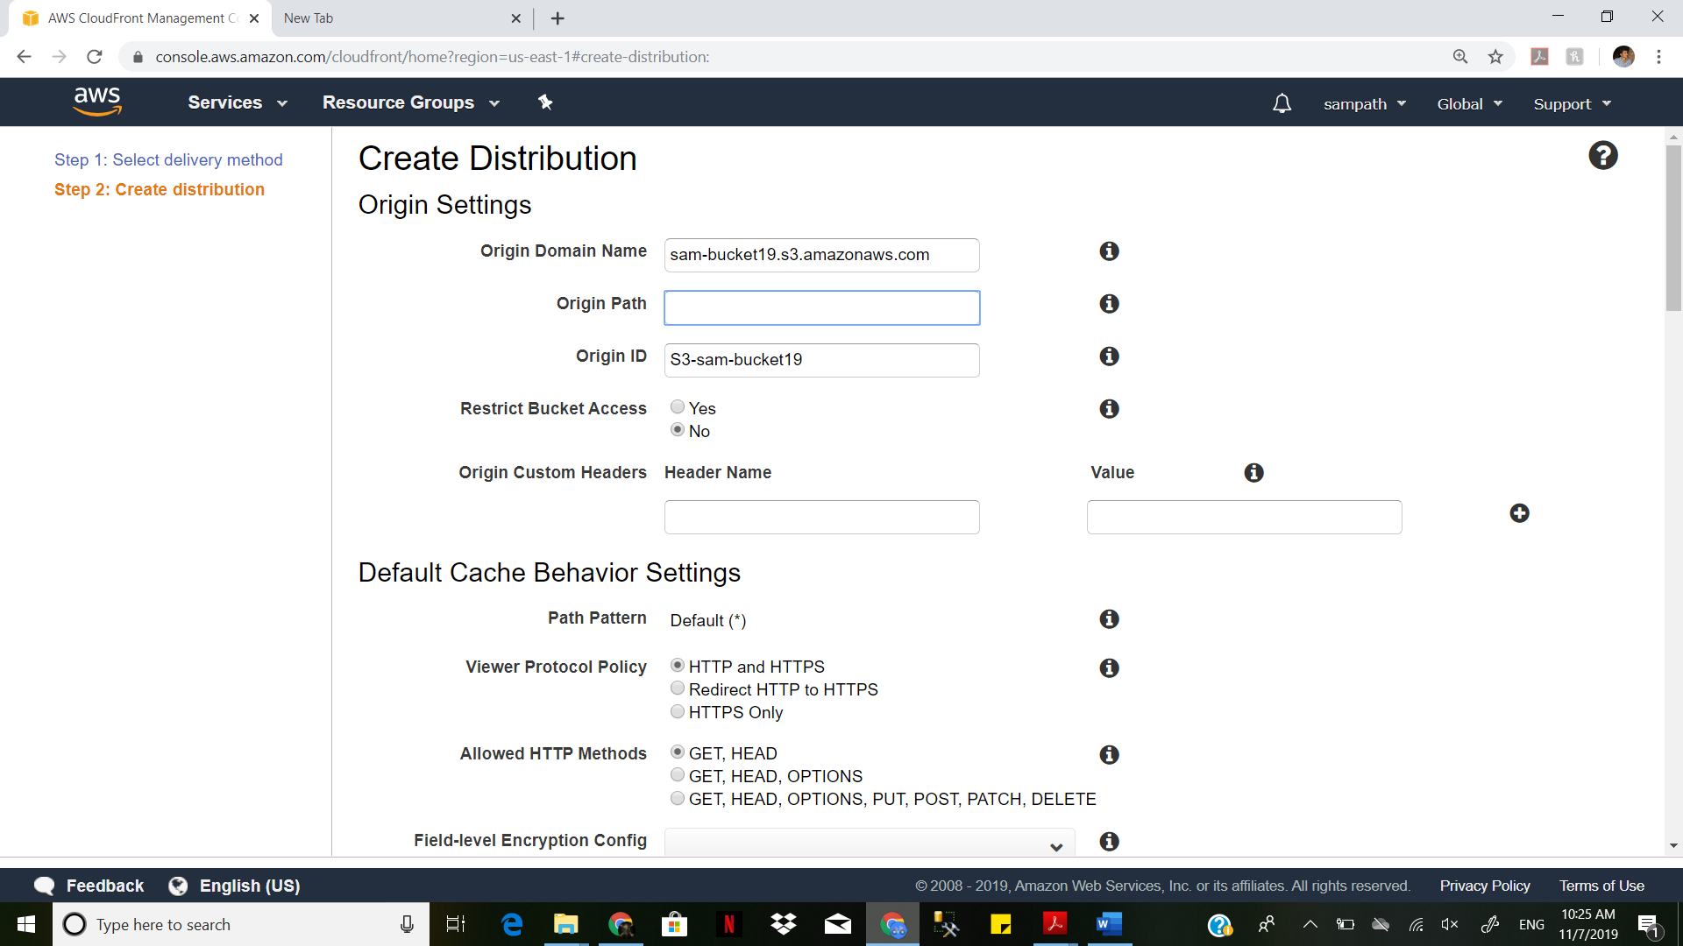

After CloudFront has created your distribution, the value of the Status column for your distribution will change from InProgress to Deployed. If you chose to enable the distribution, it will then be ready to process requests. This typically takes between 20 and 40 minutes.

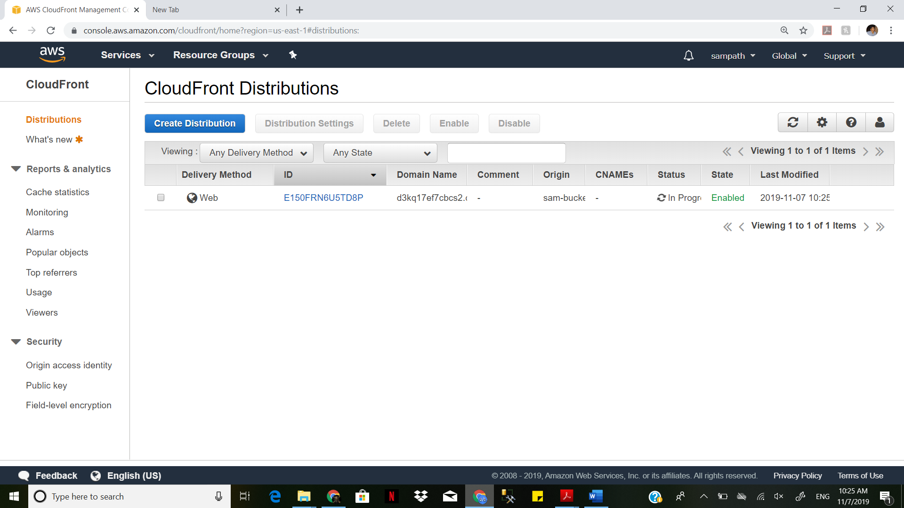

Test your links :

After you've created your distribution, CloudFront knows where your Amazon S3 origin server is, and you know the domain name associated with the distribution.

You can create a link to your Amazon S3 bucket content with that domain name and have CloudFront serve it.

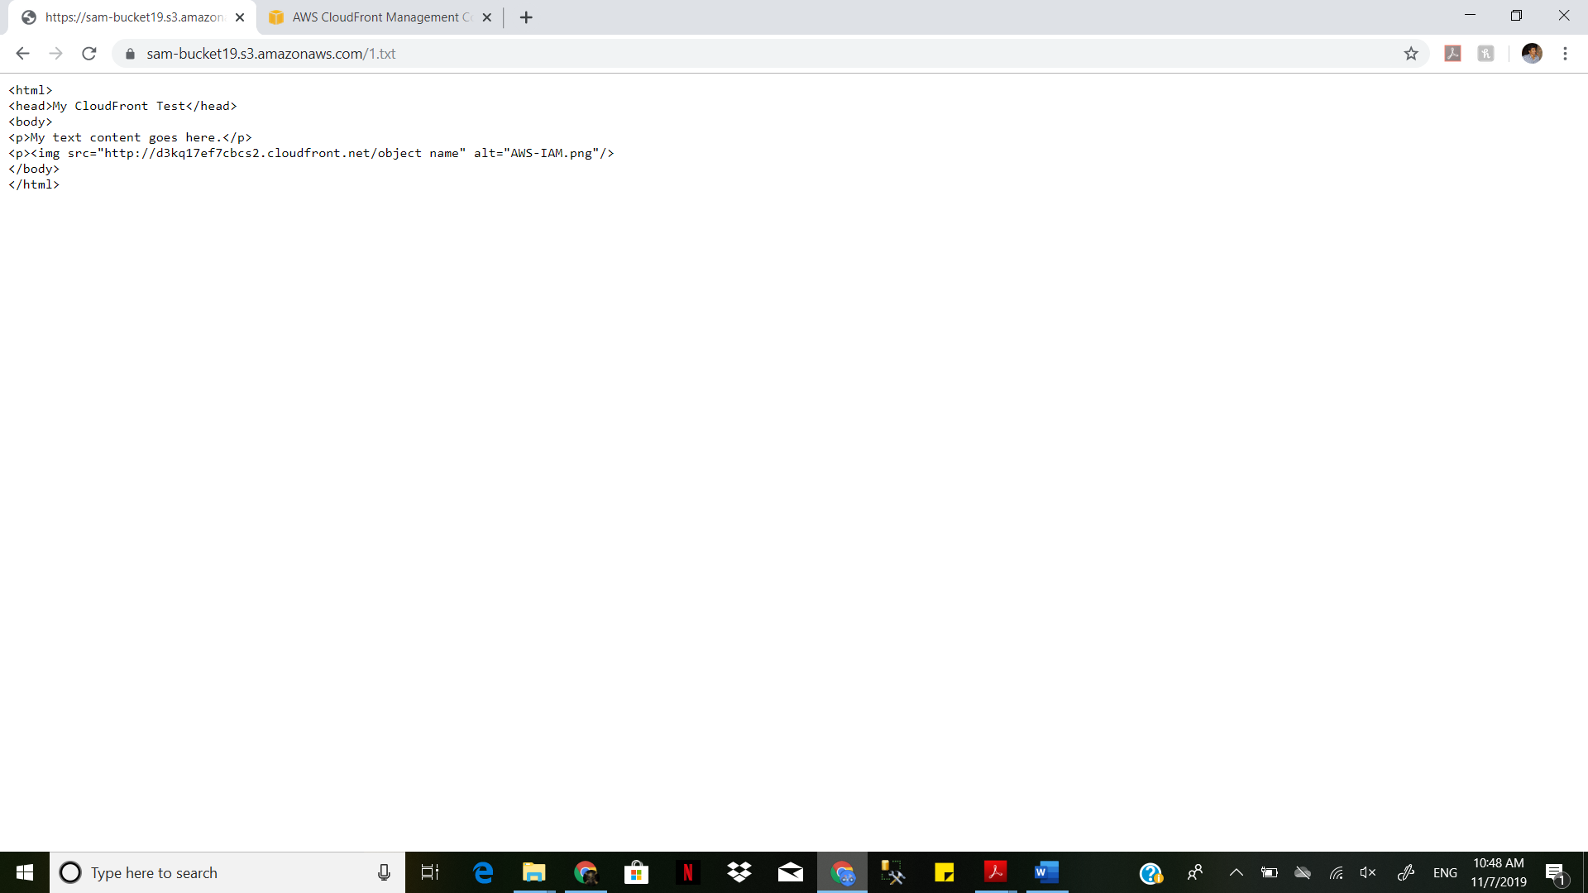

Copy the following HTML into a new file:

Replace with the domain name that CloudFront assigned to your distribution.

<html>

<head>My CloudFront Test</head>

<body>

<p>My text content goes here.</p>

<p><img src="http://d3kq17ef7cbcs2.cloudfront.net/1.jpg>

</body>

</html>

For example, if your domain name was d111111abcdef8.cloudfront.net and your object was image.jpg, the URL for the link would be: http://d111111abcdef8.cloudfront.net/1.jpg.

If your object is in a folder within your bucket, include the folder in the URL. For example, if 1.jpg is located in an images folder, then the URL would be: http://d111111abcdef8.cloudfront.net/1.jpg

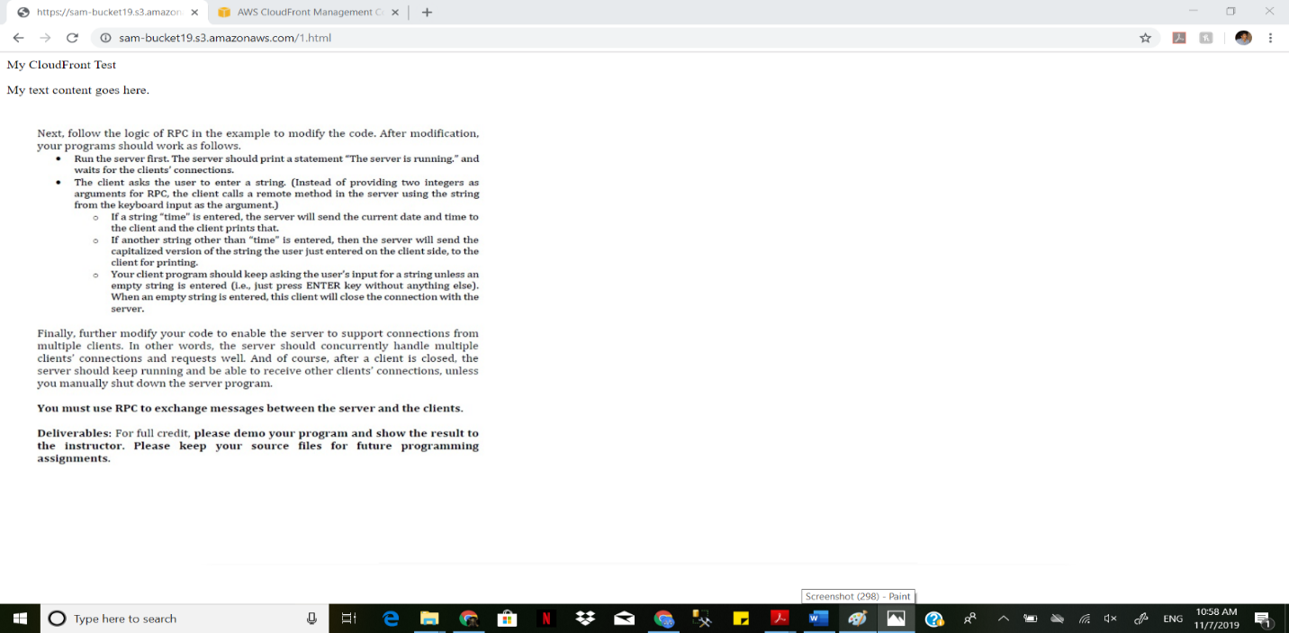

Save the text in a file that has a .html filename extension. 11.Open your web page in a browser to ensure that you can see your content. If you cannot see the content, confirm that you have performed all of the steps correctly.

**7c: AWS Security**

**Open IAM**

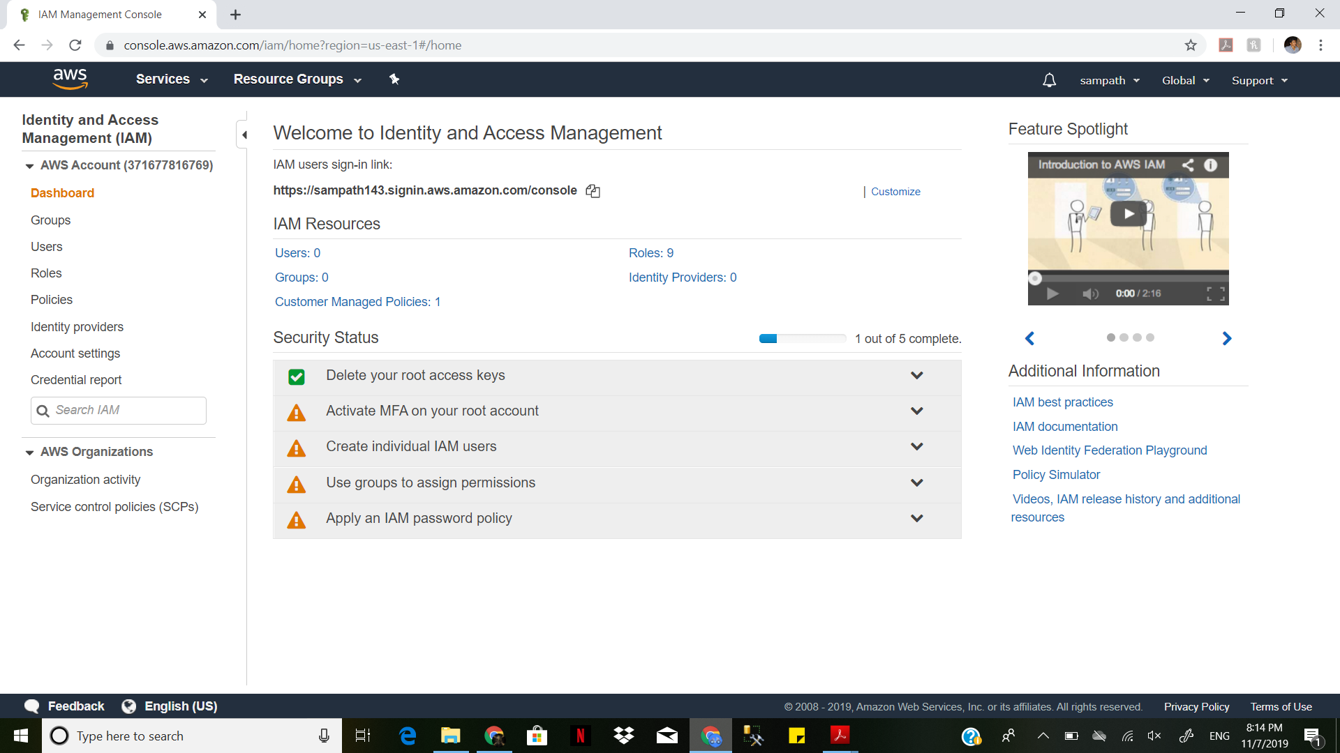

Creating a group in IAM

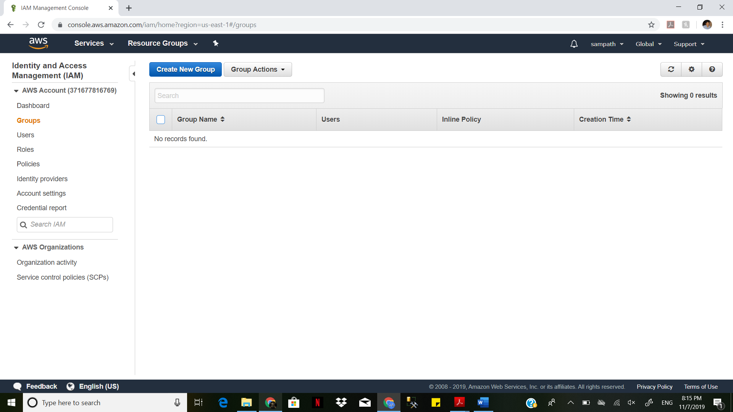

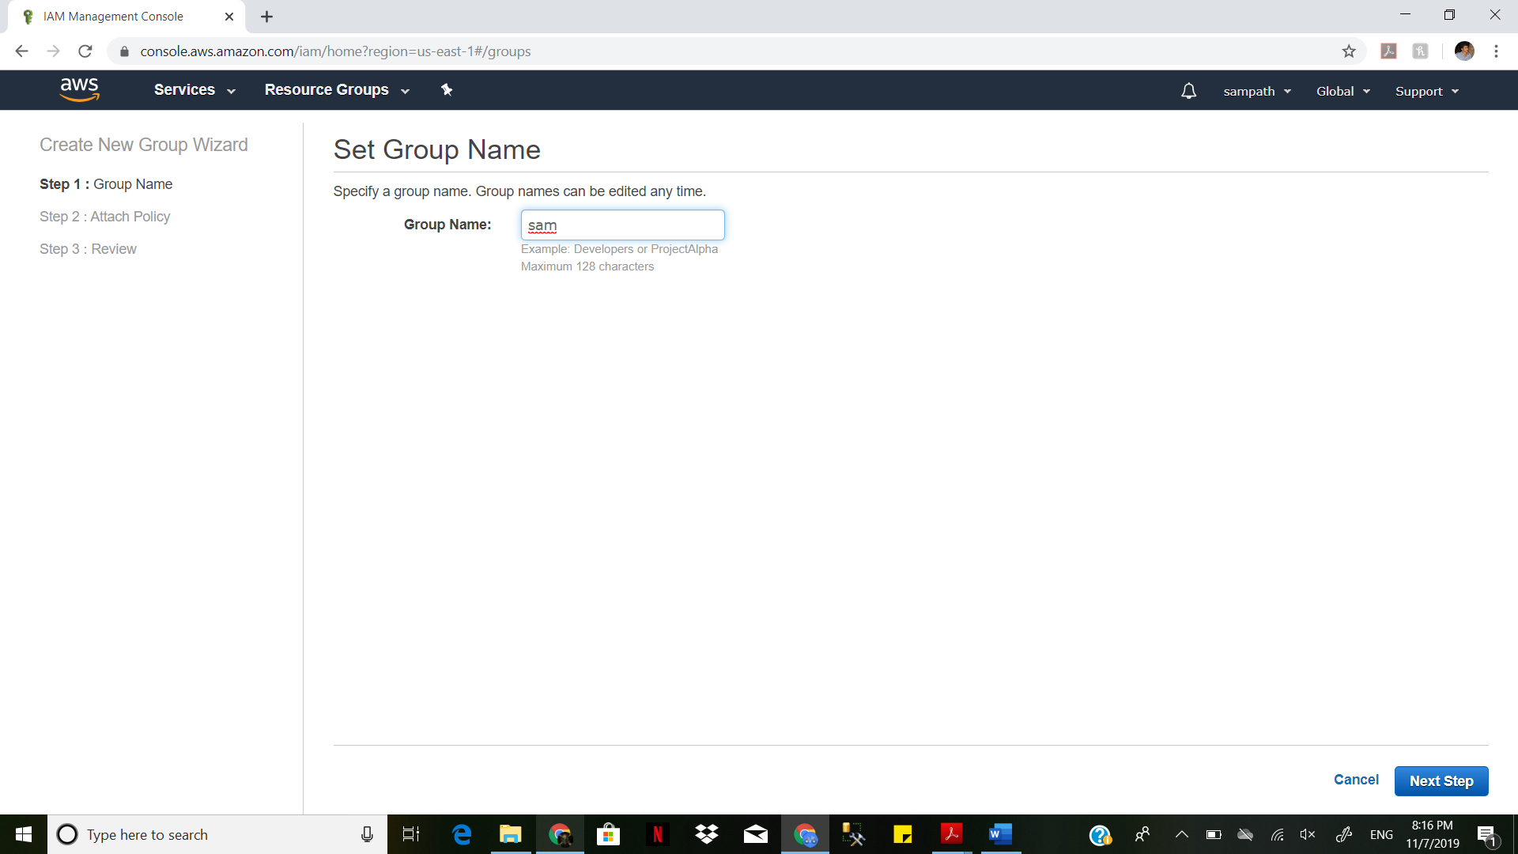

Give full ec2 access

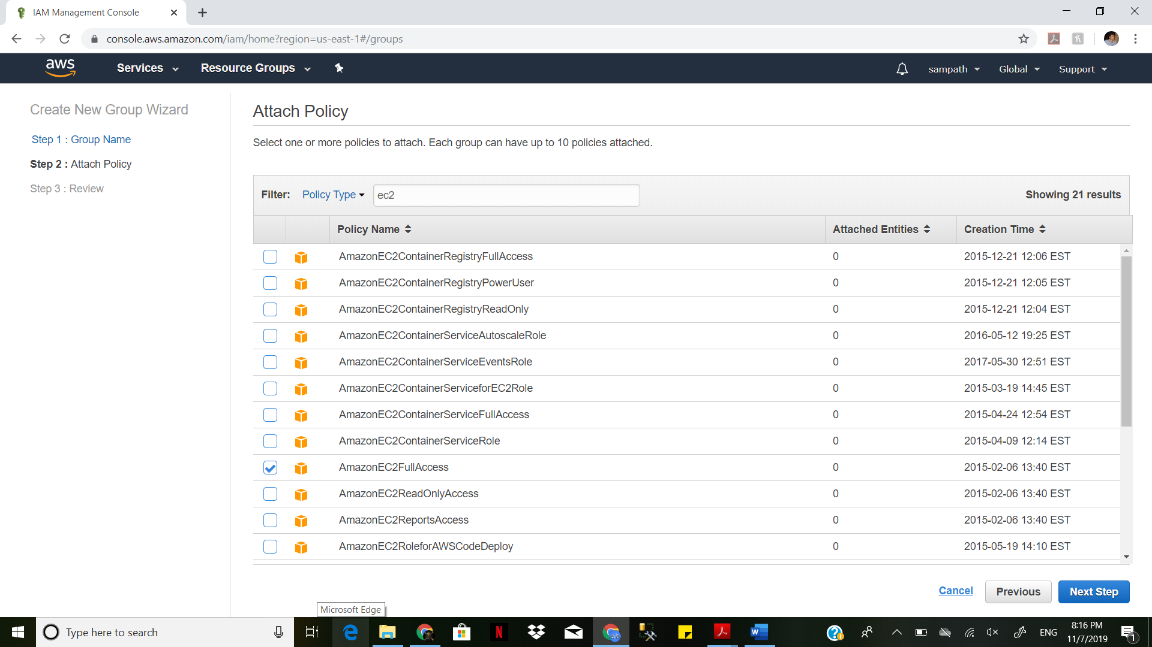

Group is created with ec2 full access

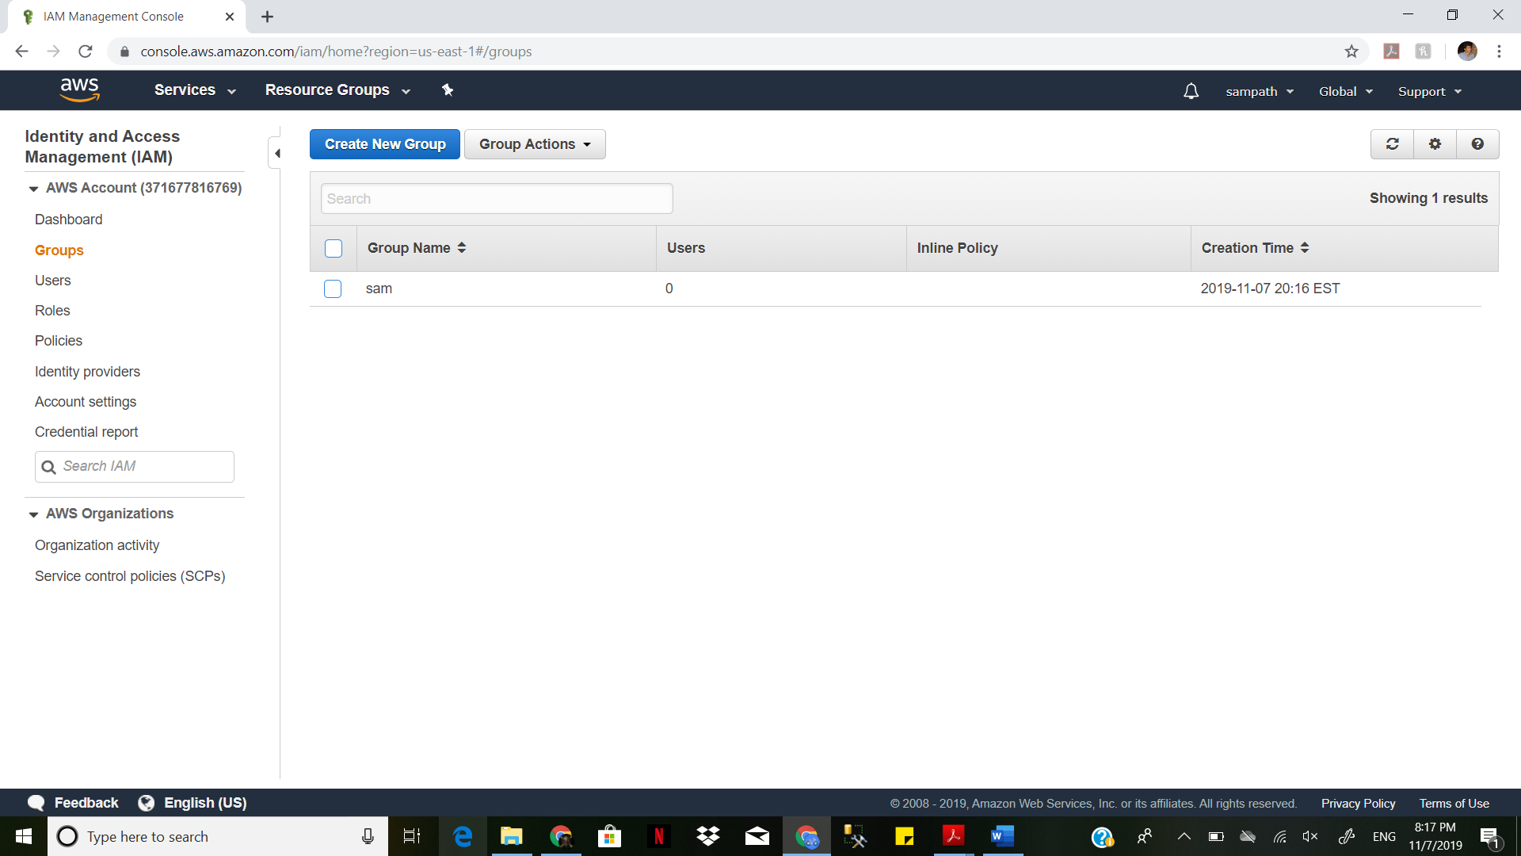

Changing the alias for the account to **sam28**

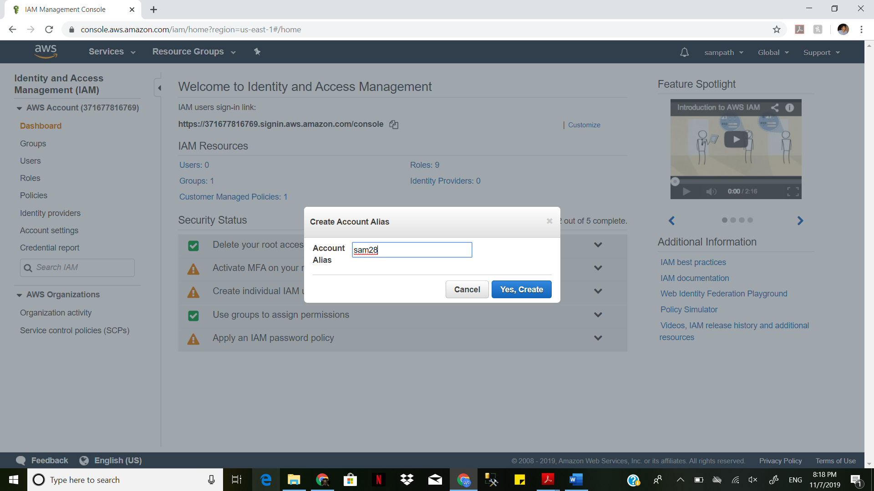

[**https://sam2803.signin.aws.amazon.com/console**](https://sam2803.signin.aws.amazon.com/console)

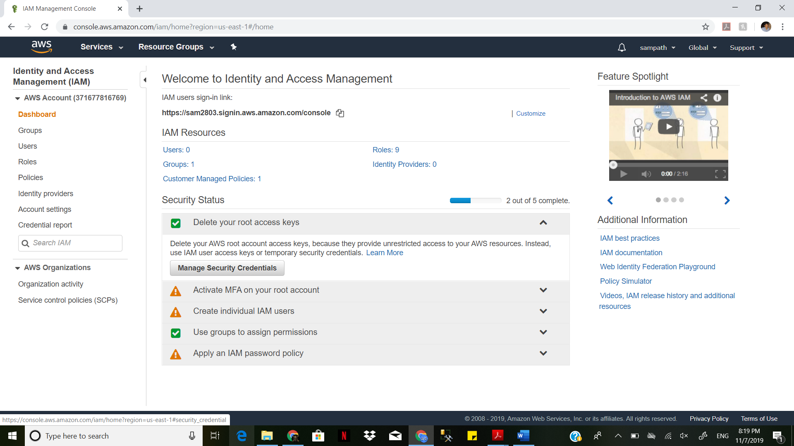

Changing security credentials

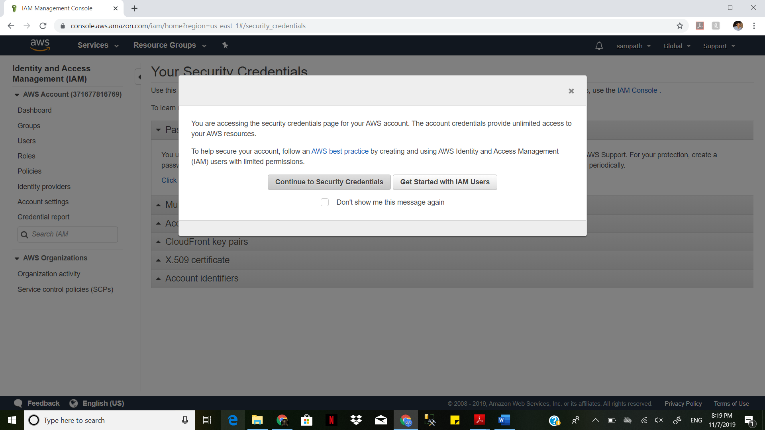

Activating MFA

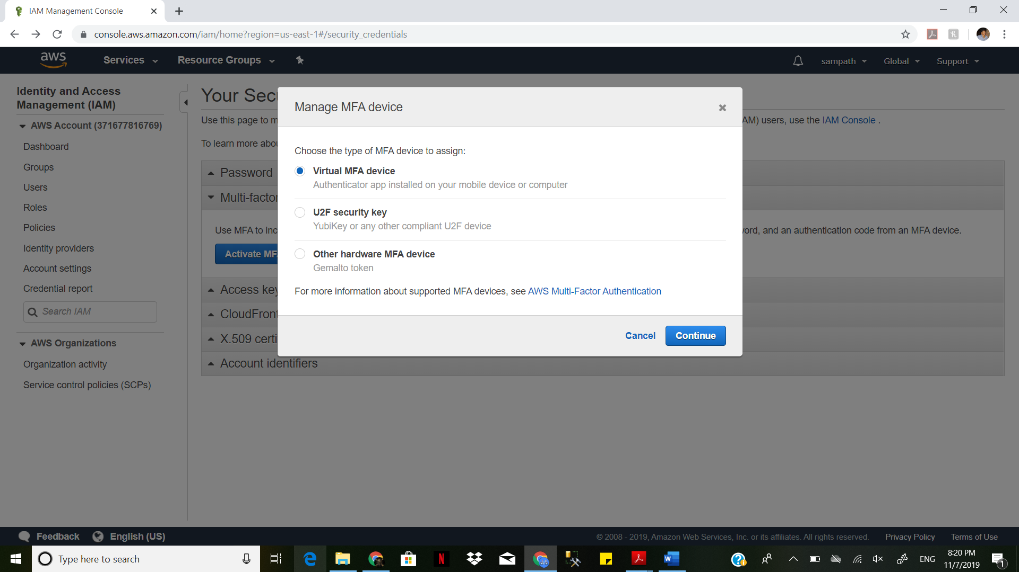

Using DUO to connect to the account

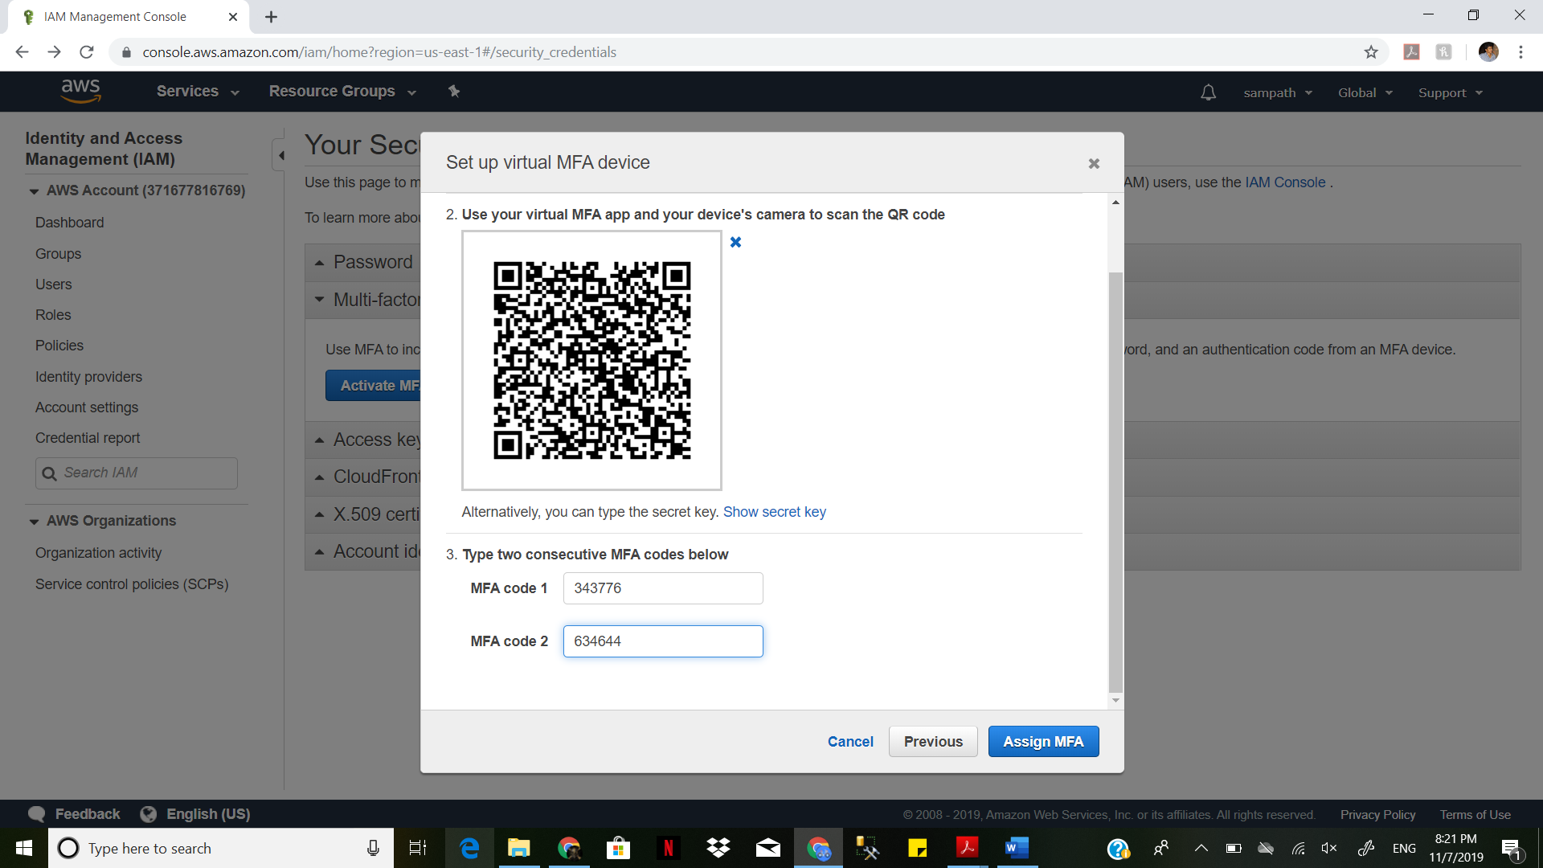

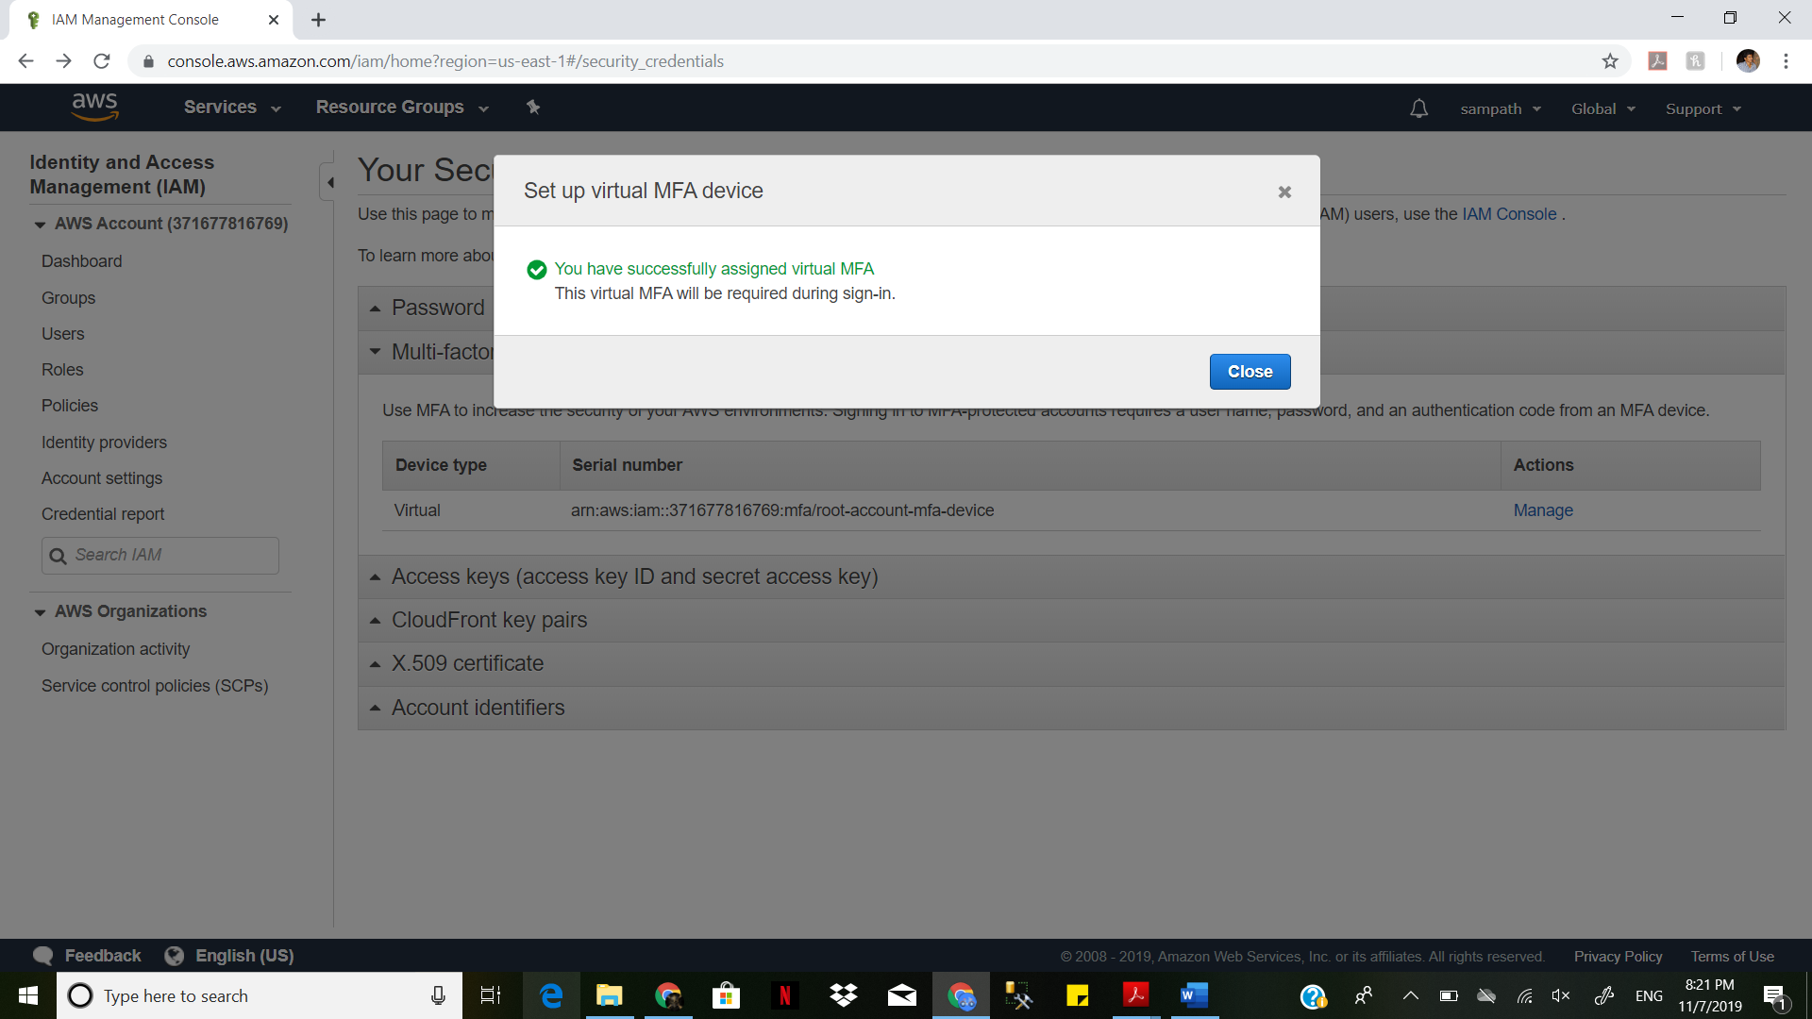

creating access key

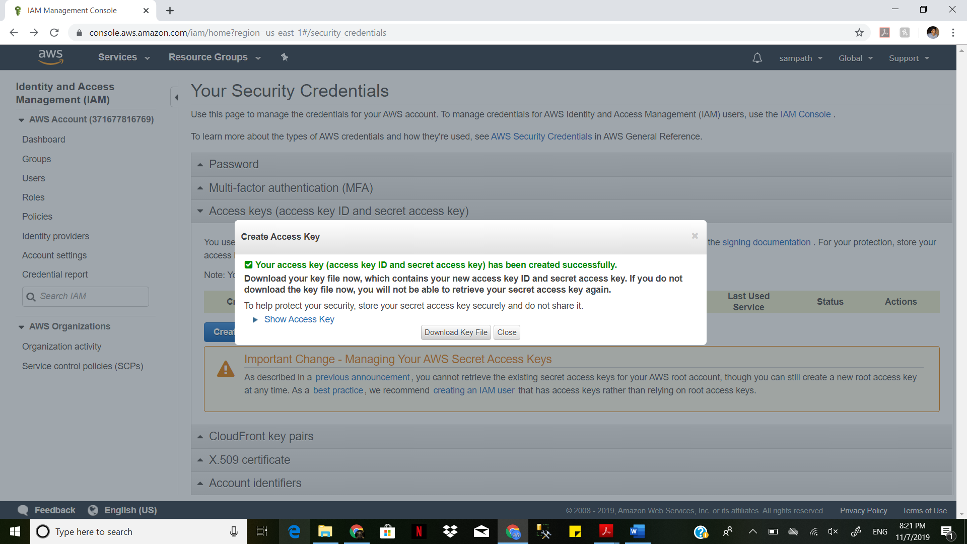

Downloading access key

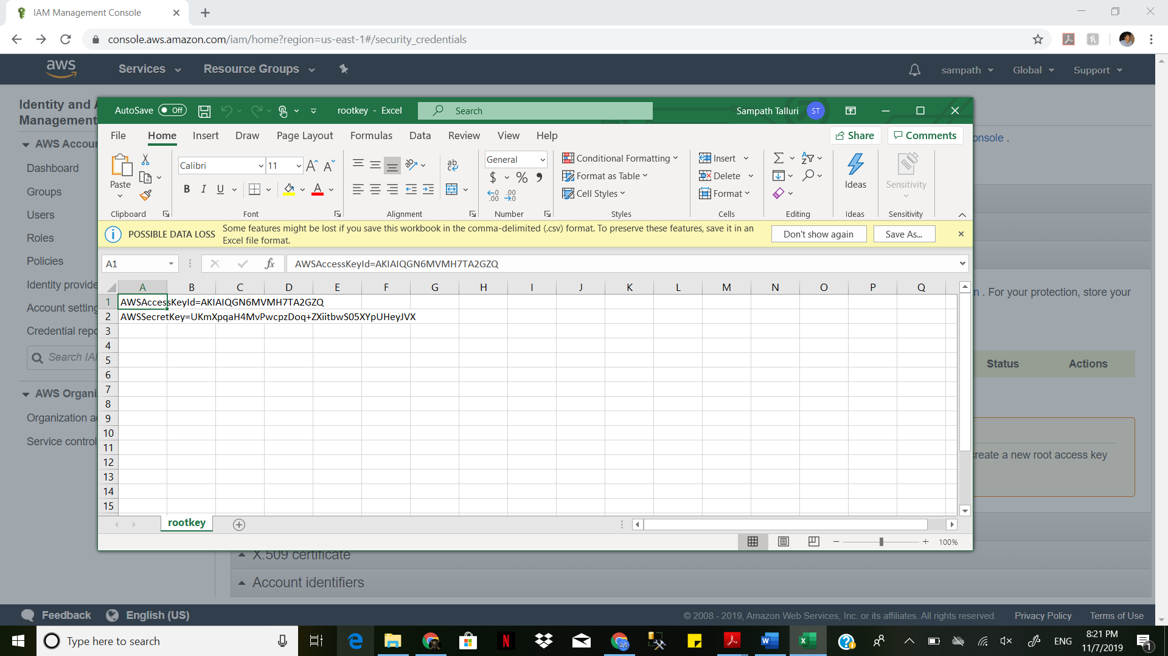

Creating cloud front key

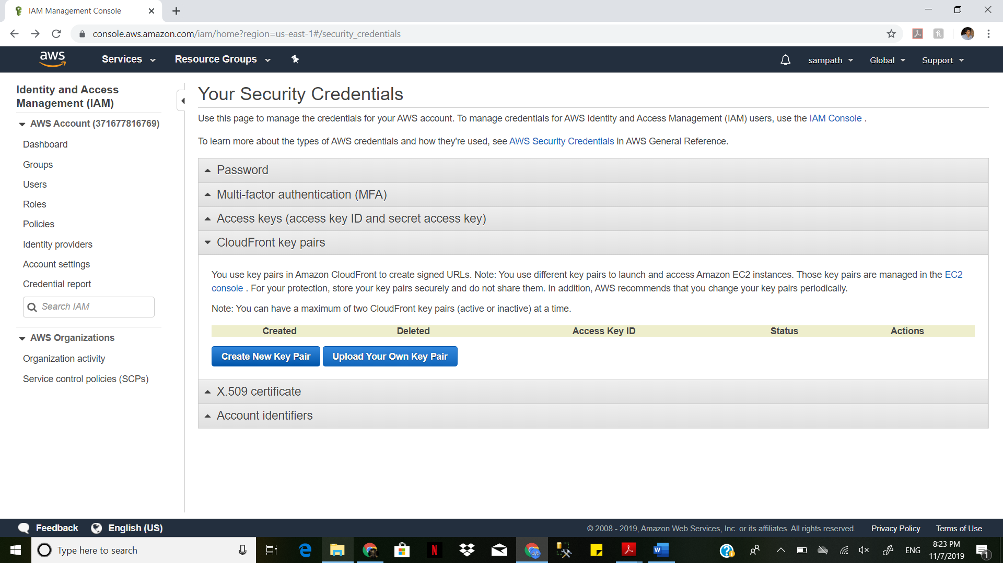

Downloading Key pair

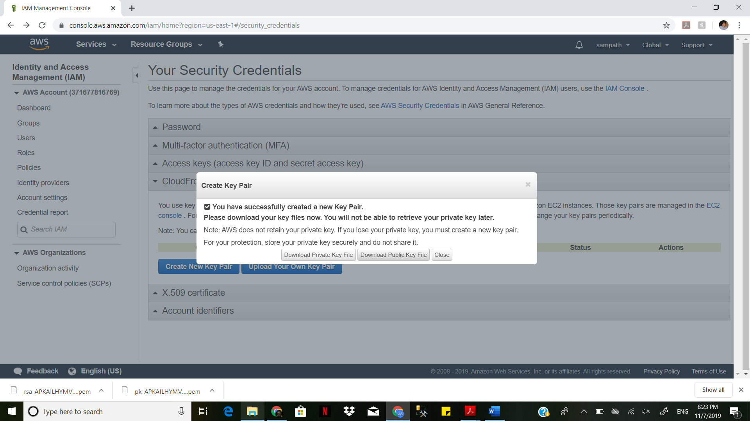

Creating x509

Download certificate

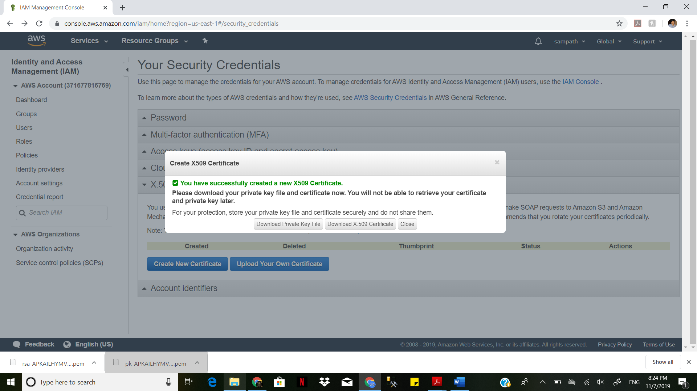

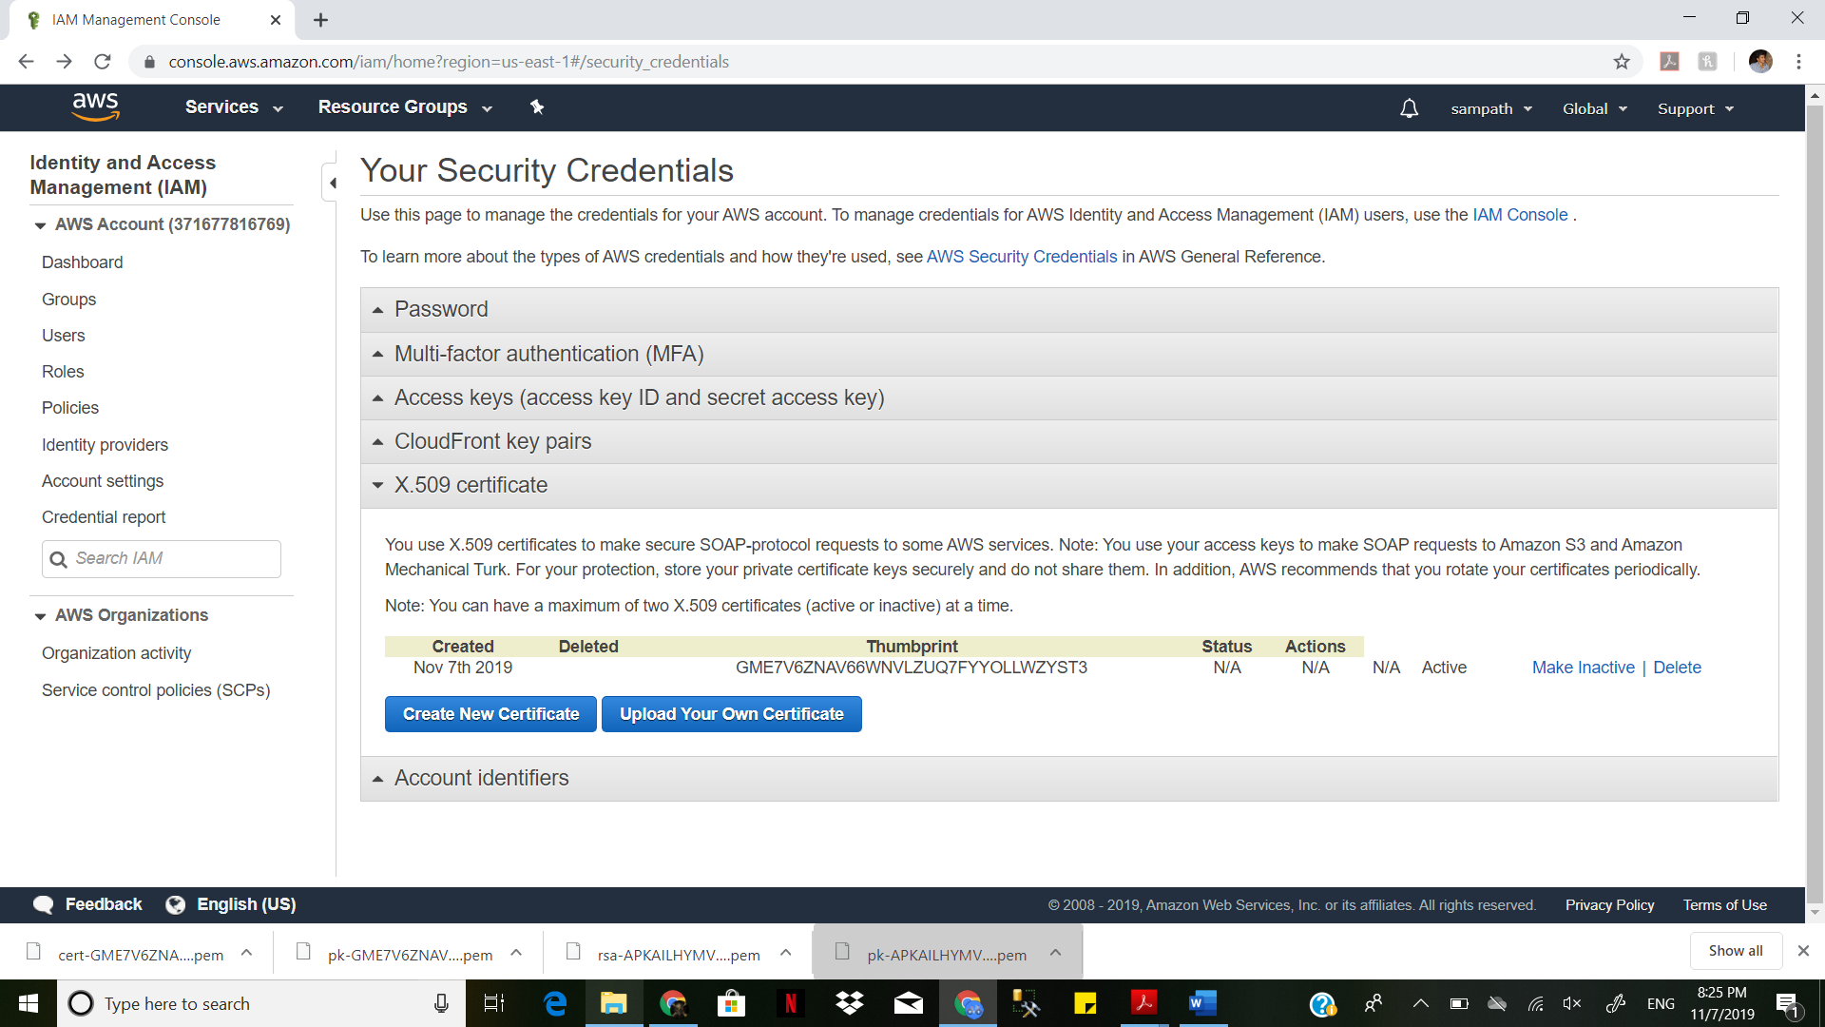

Creating IAM user

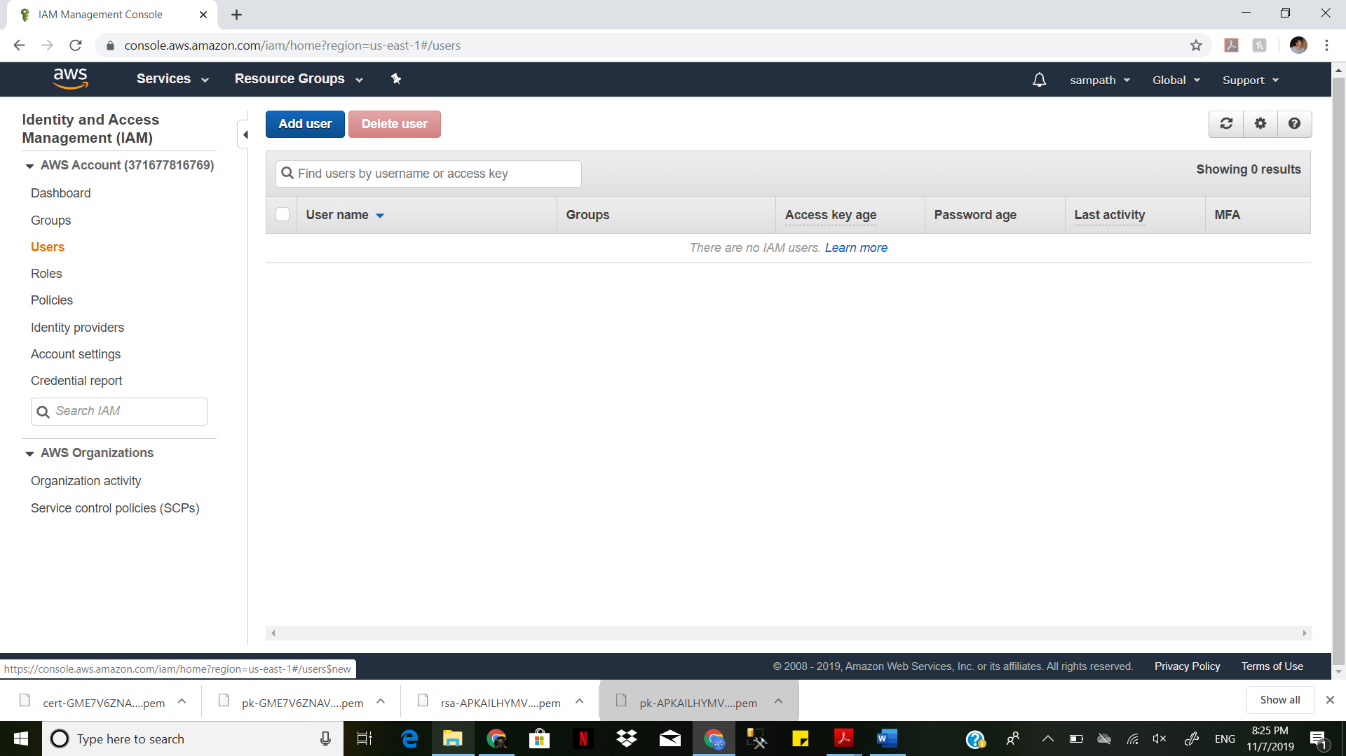

Giving programmatic access and aws management console

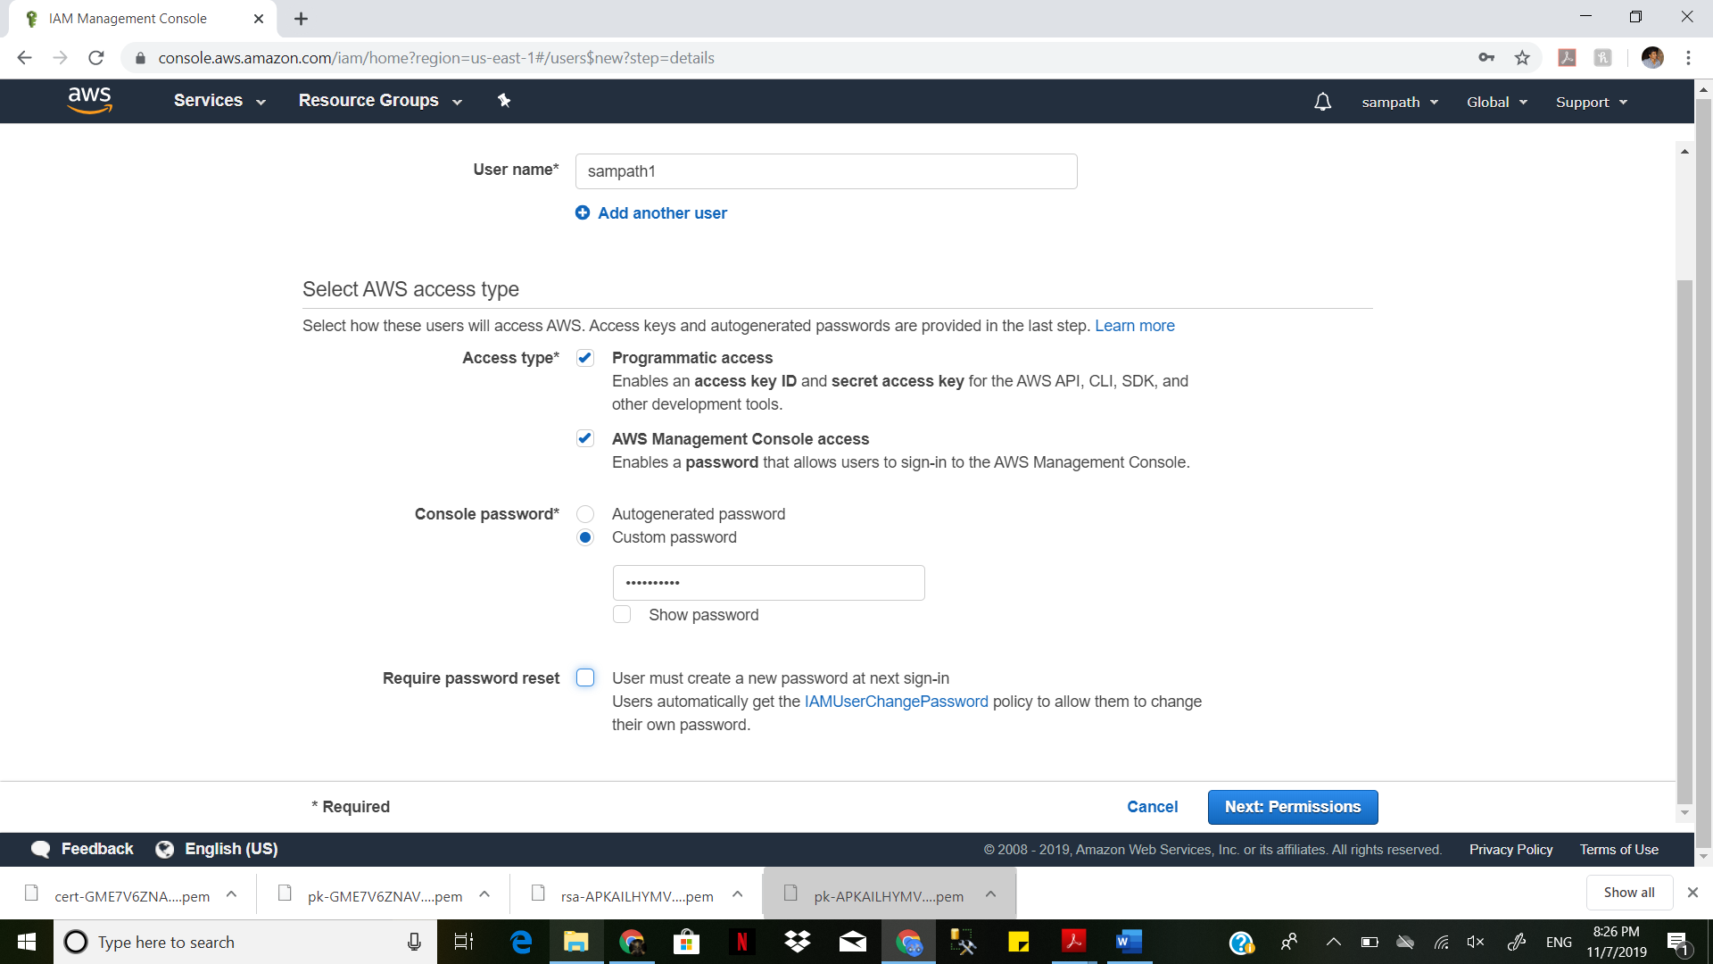

**Adding to the group**

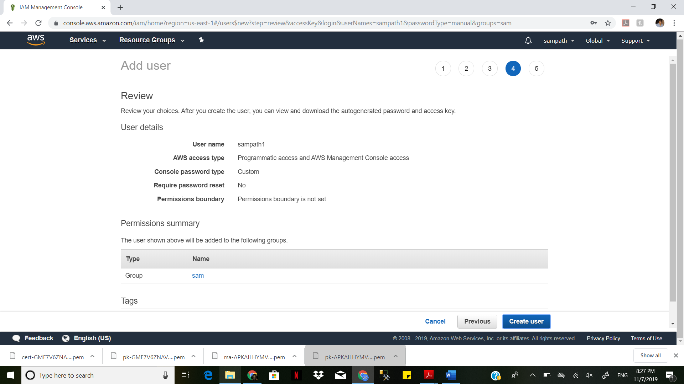

Created the user

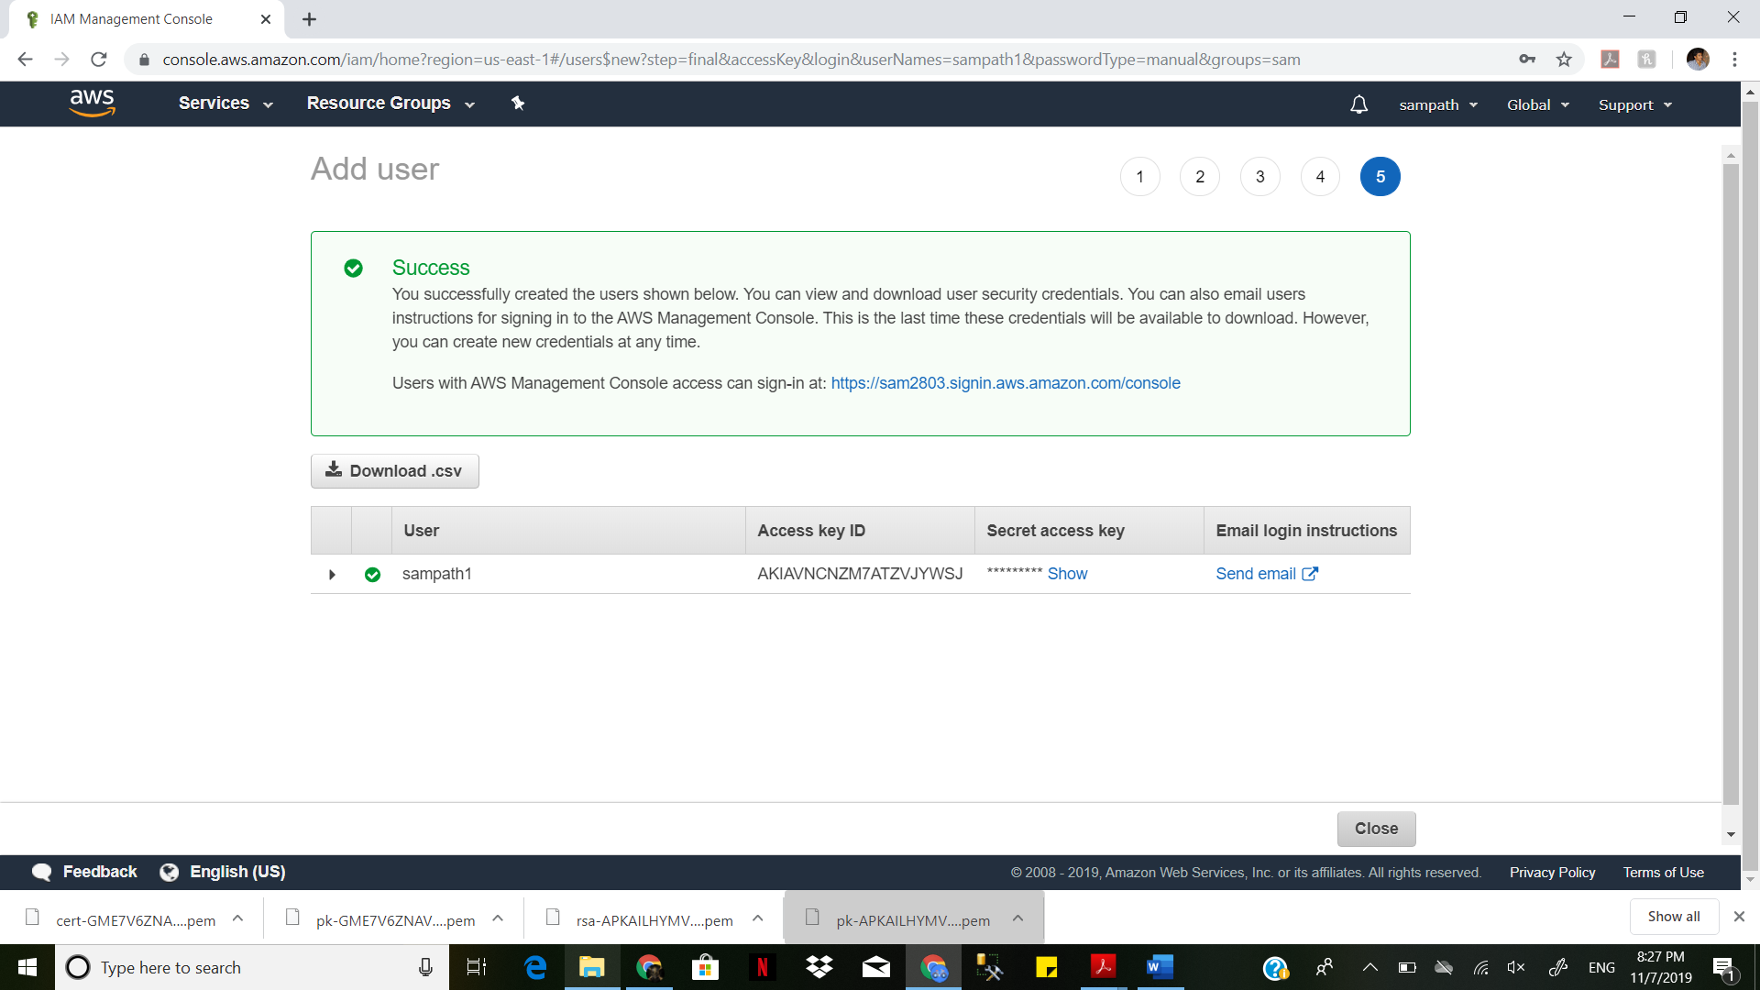

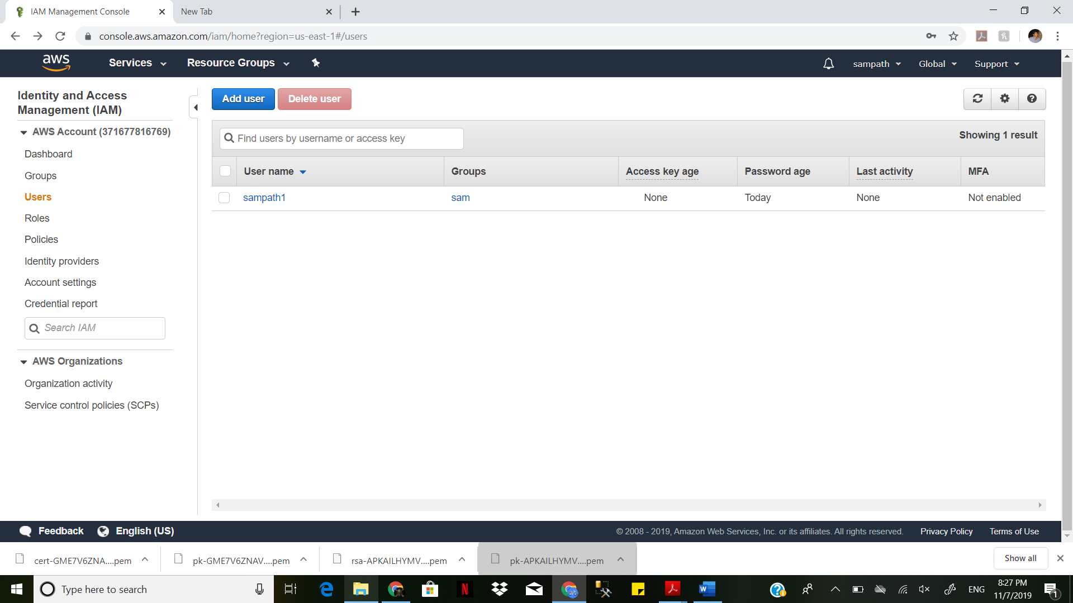

Set password policy

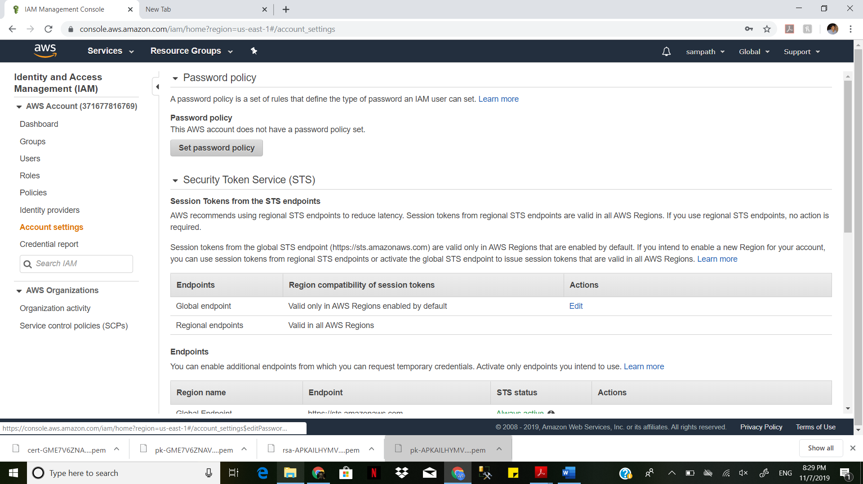

Changing the policy

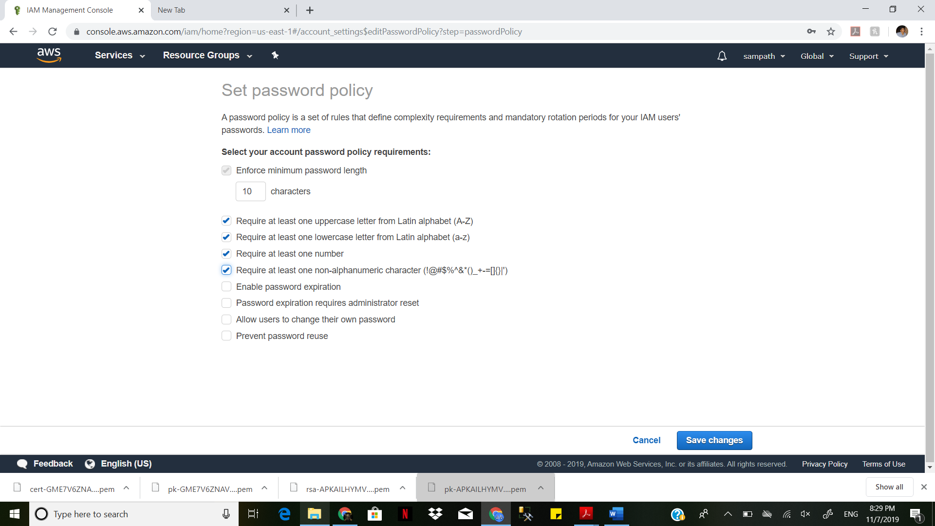

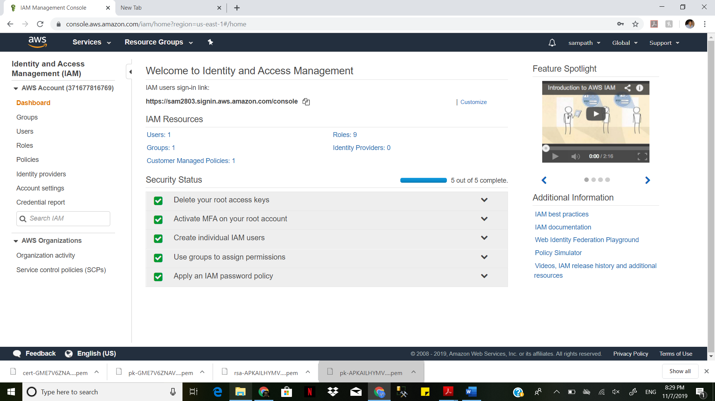

security credentials

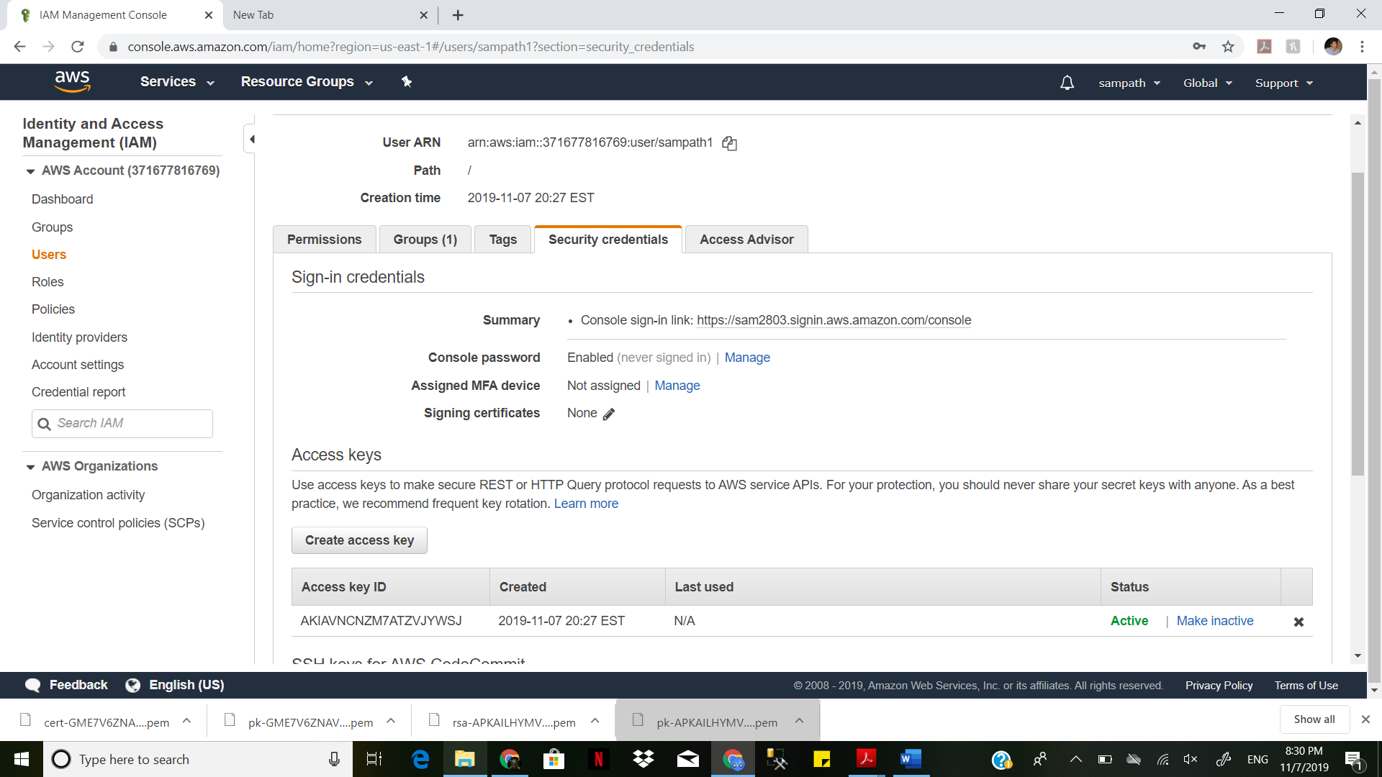

open user pools

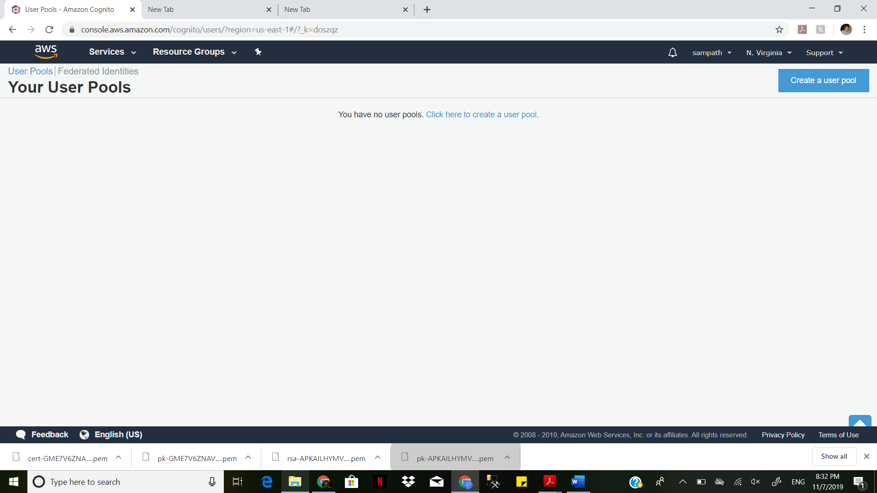

create new pool

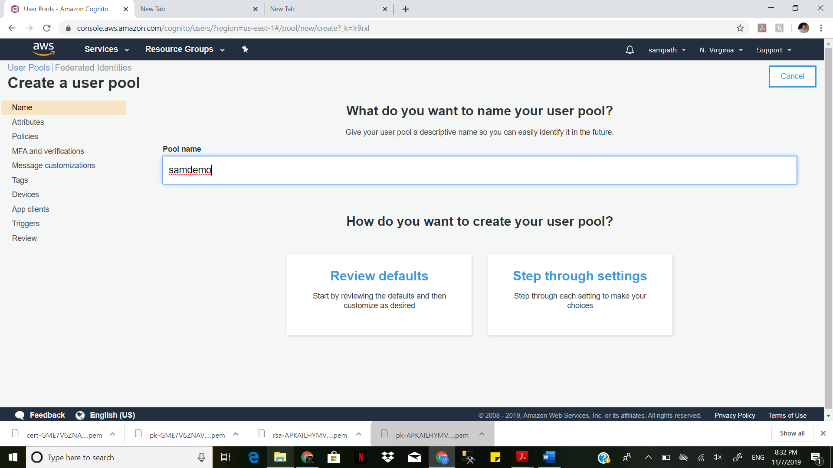

allow email and phone access

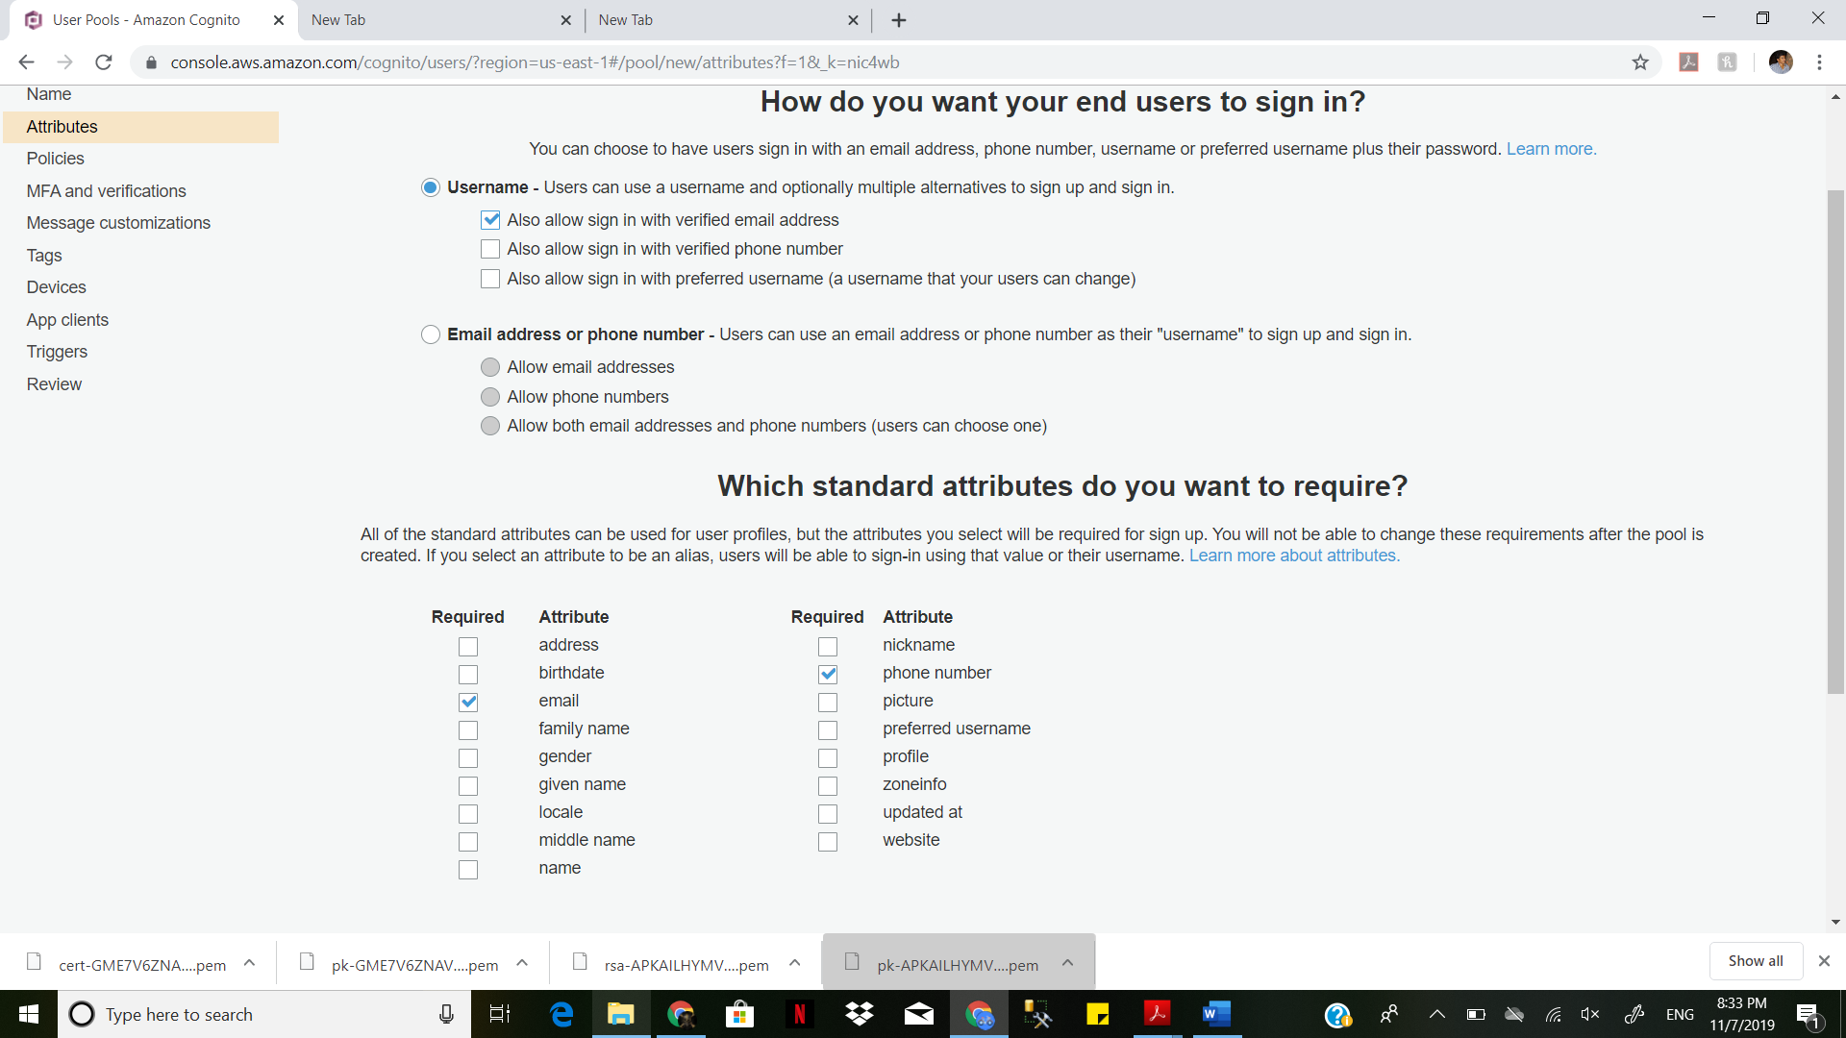

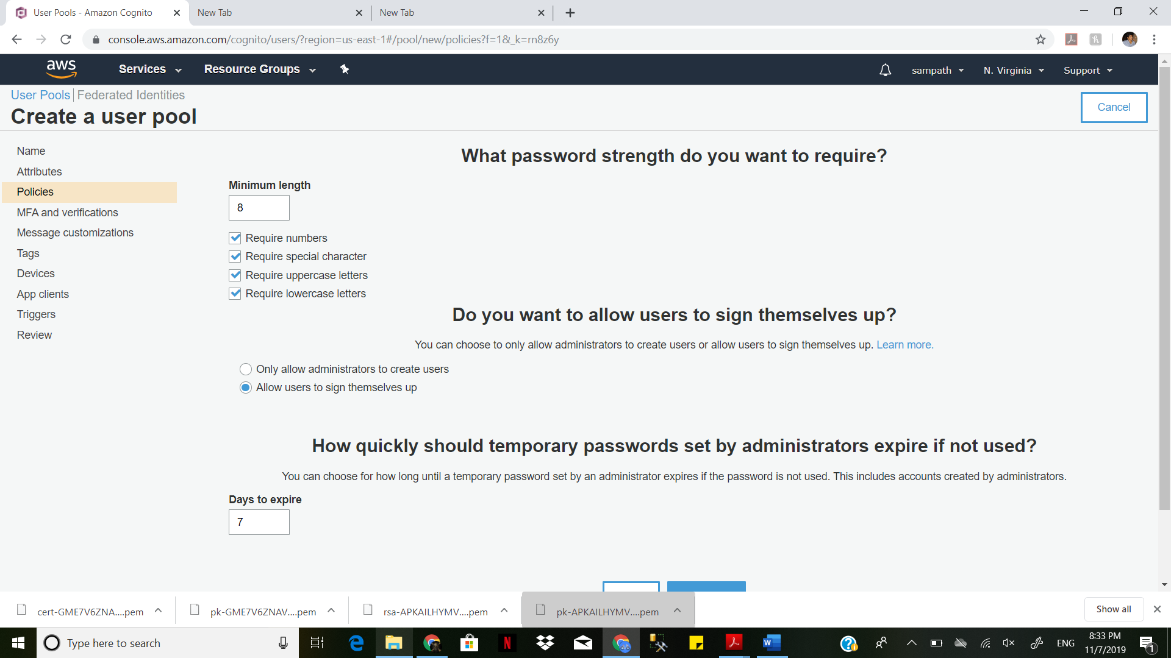

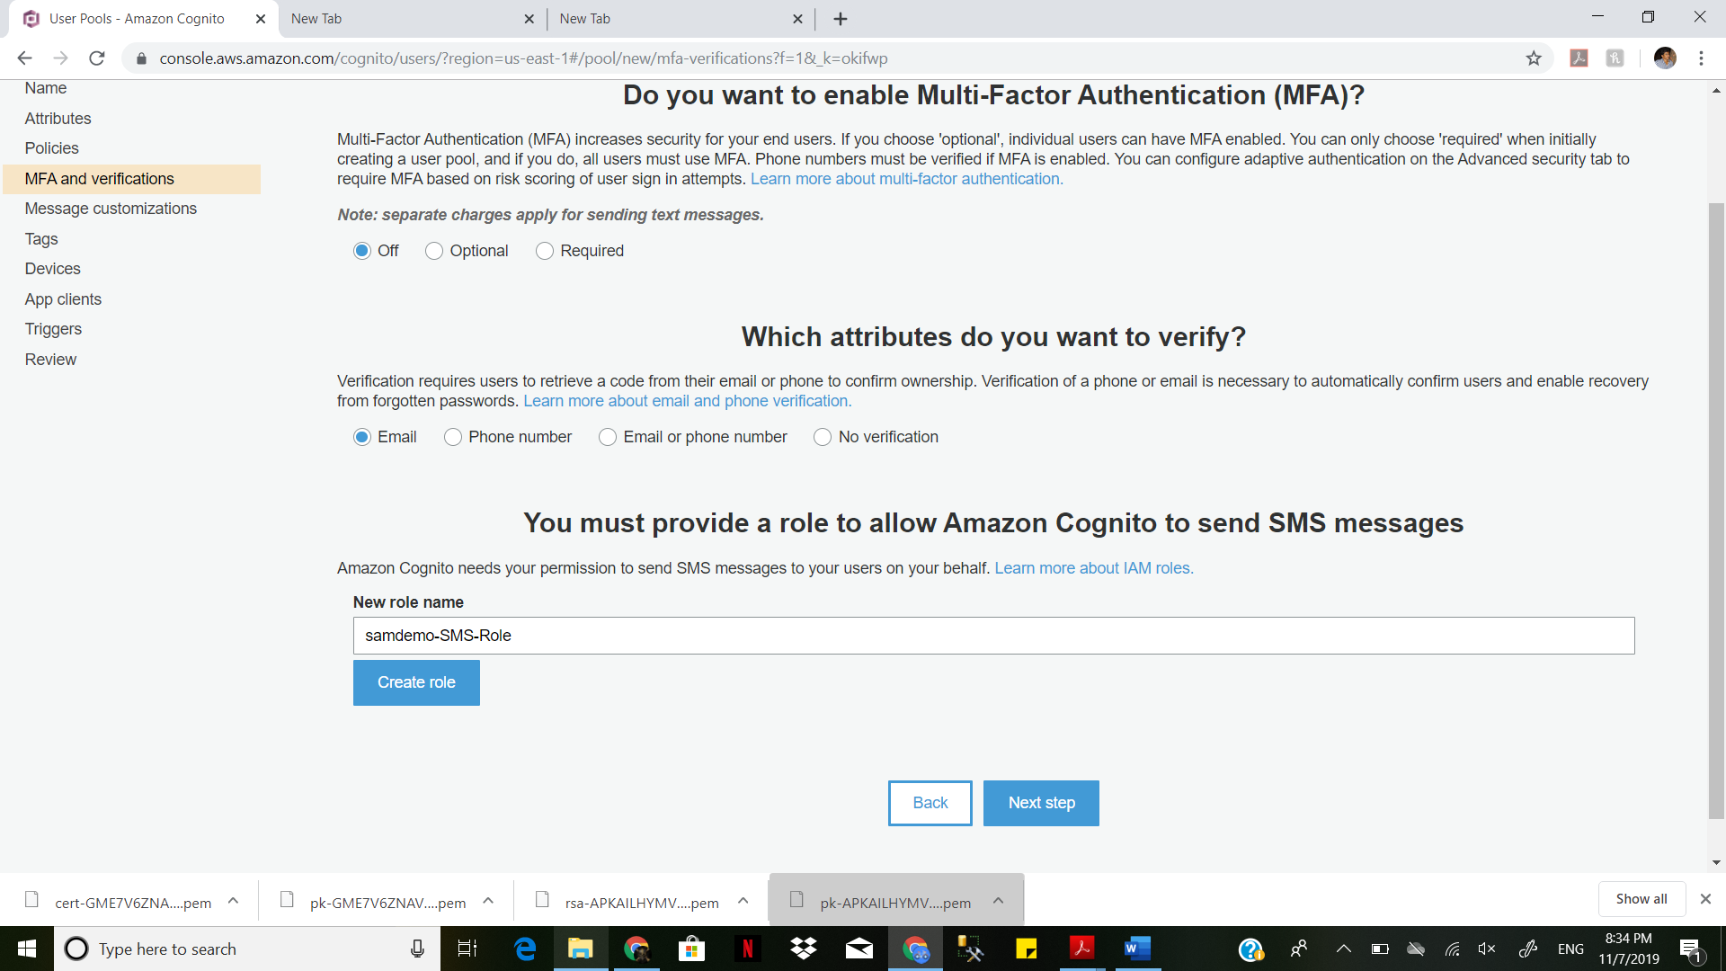

Give them all the required access

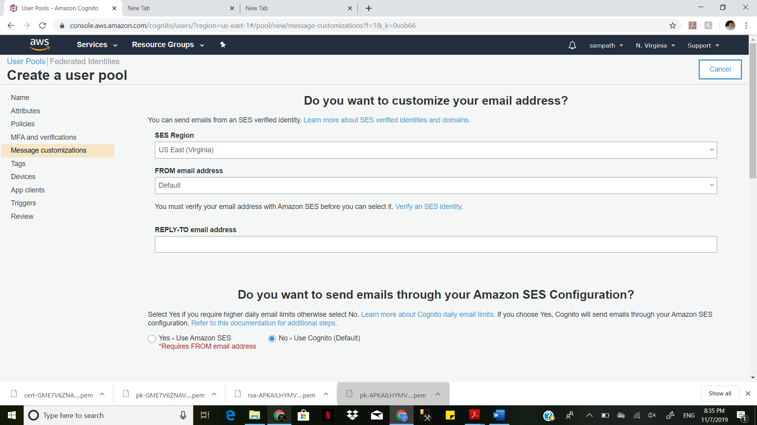

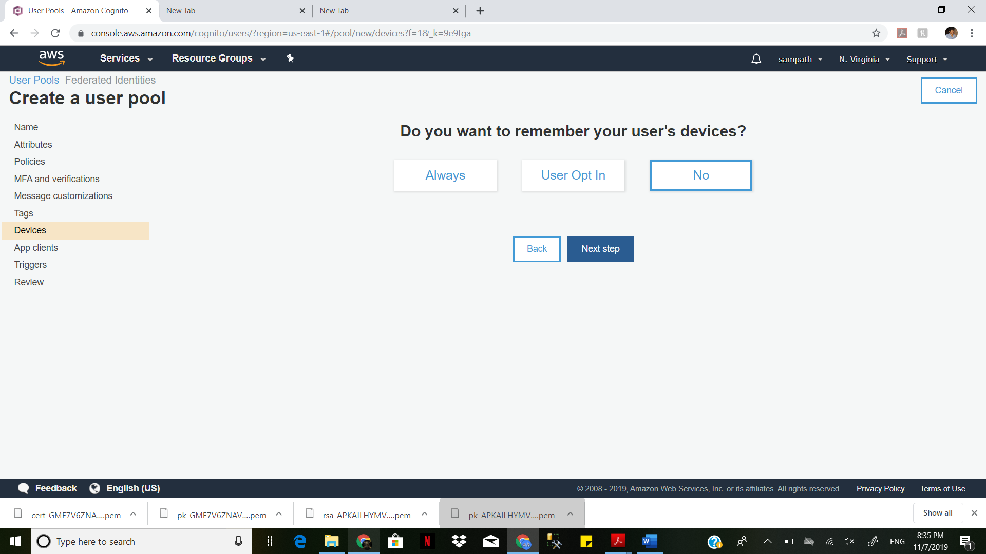

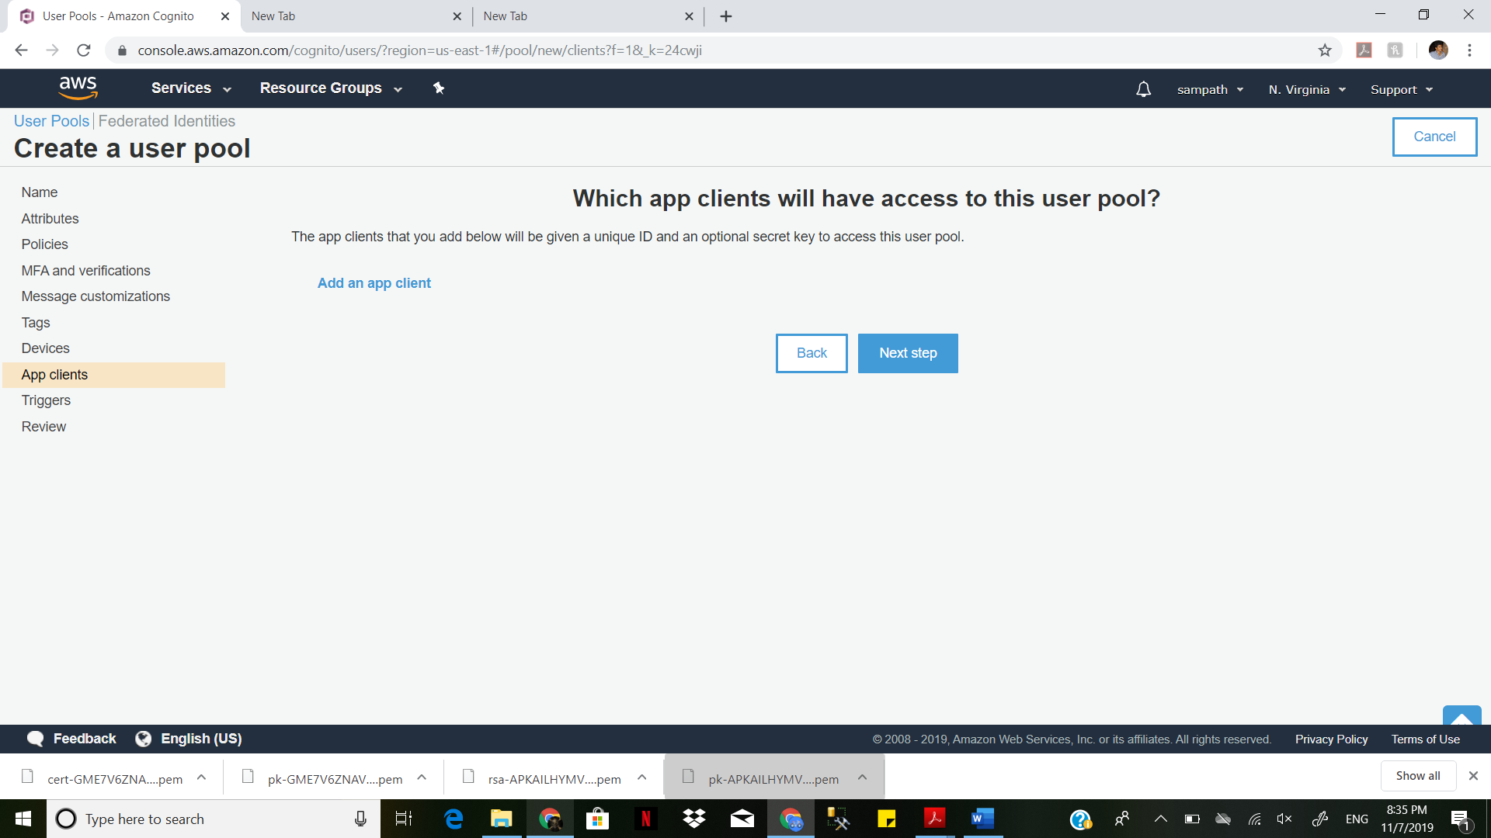

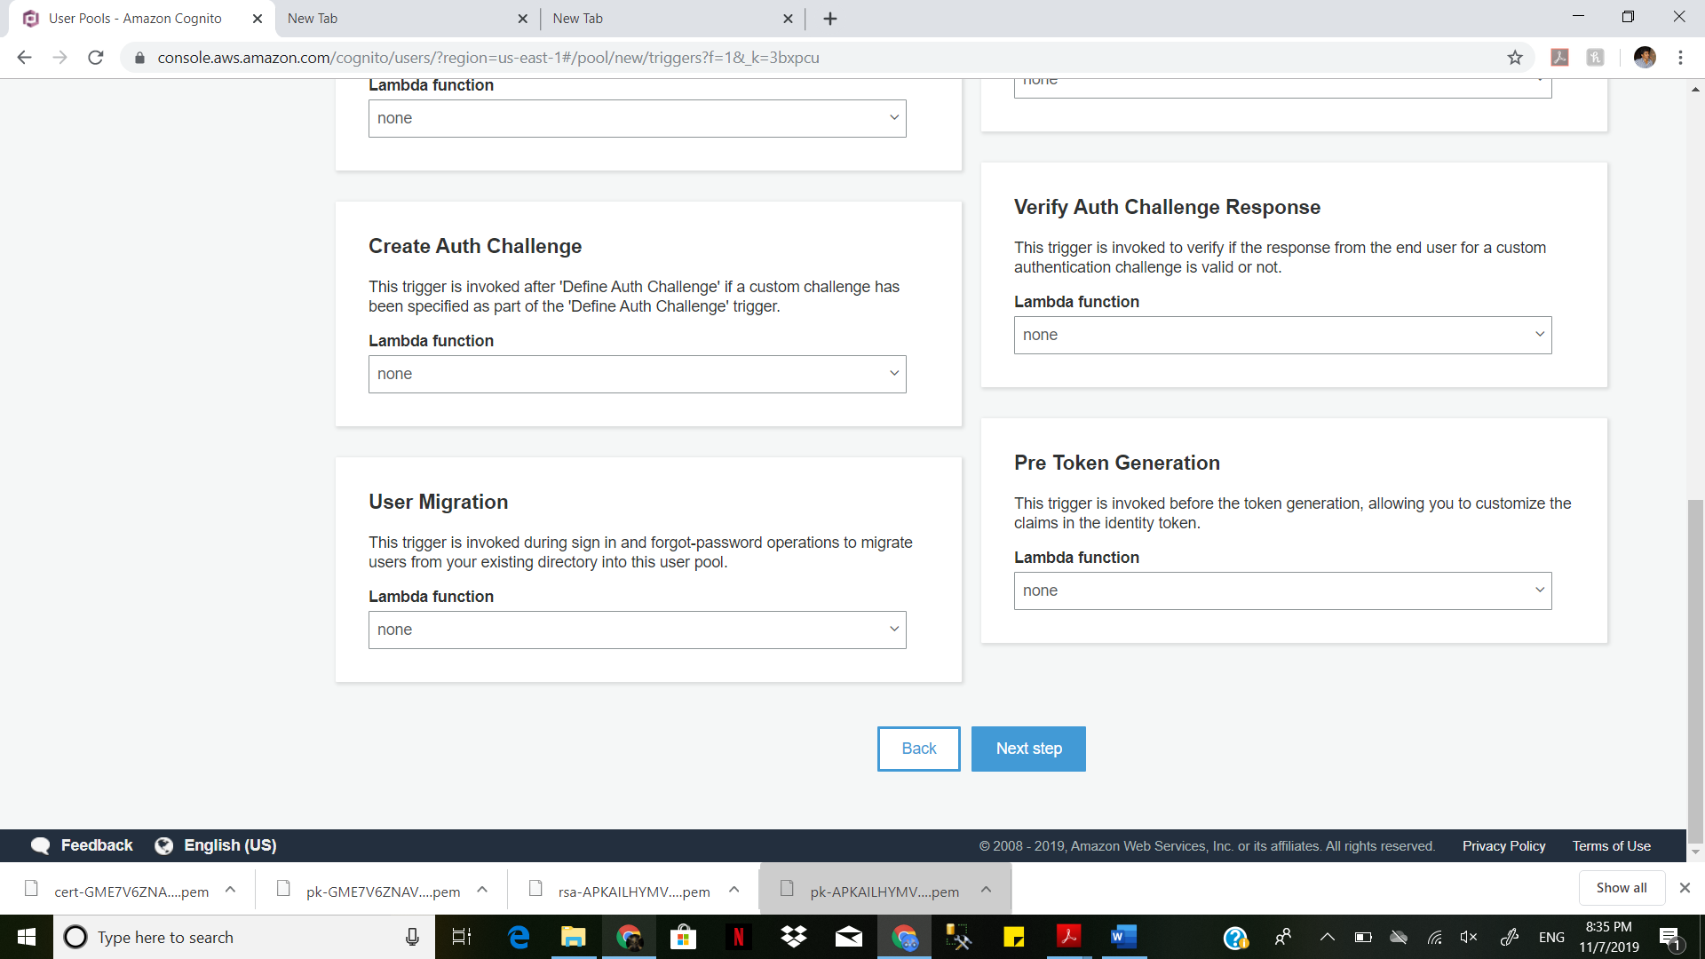

samdemo pool is created

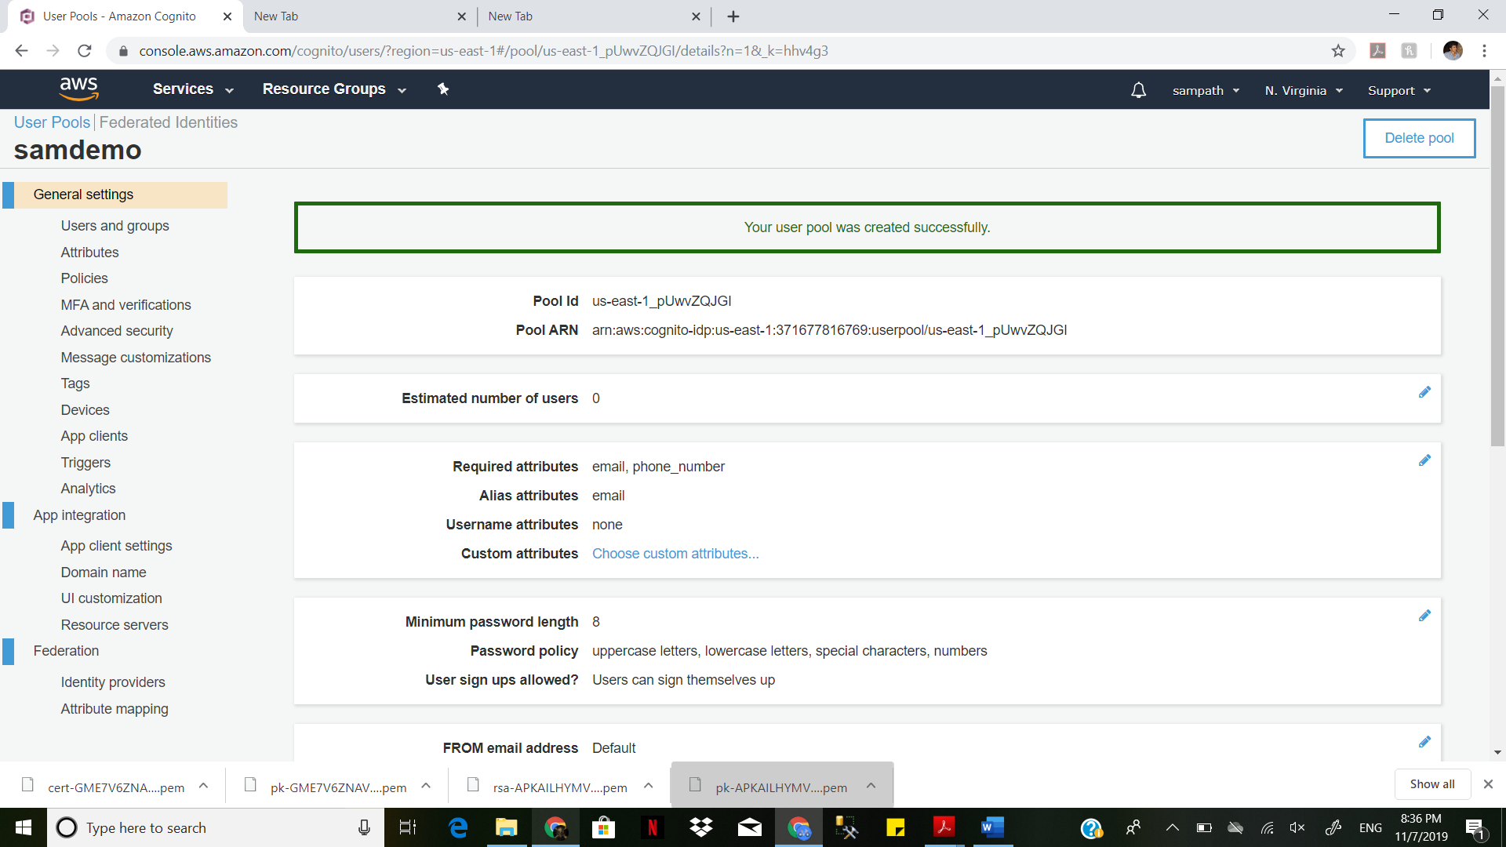

Verification with email address.

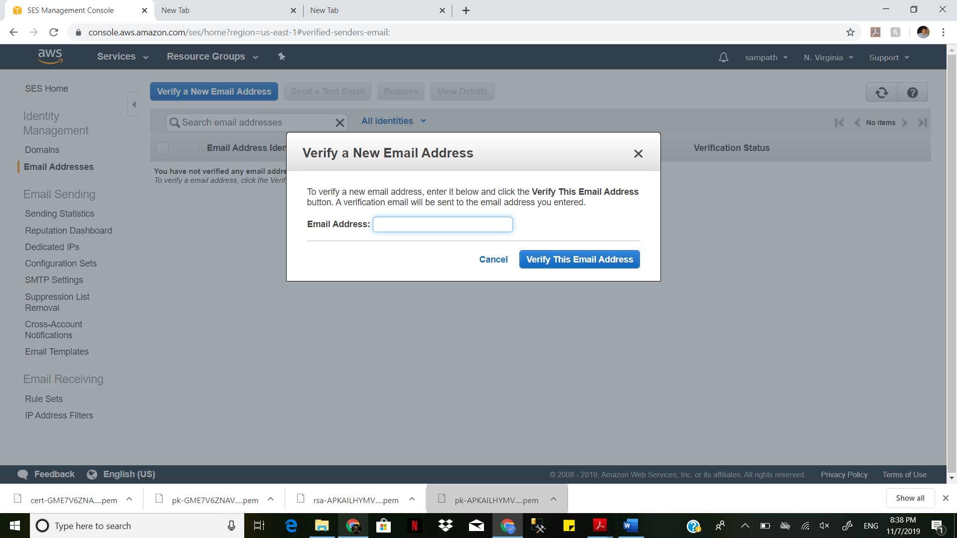

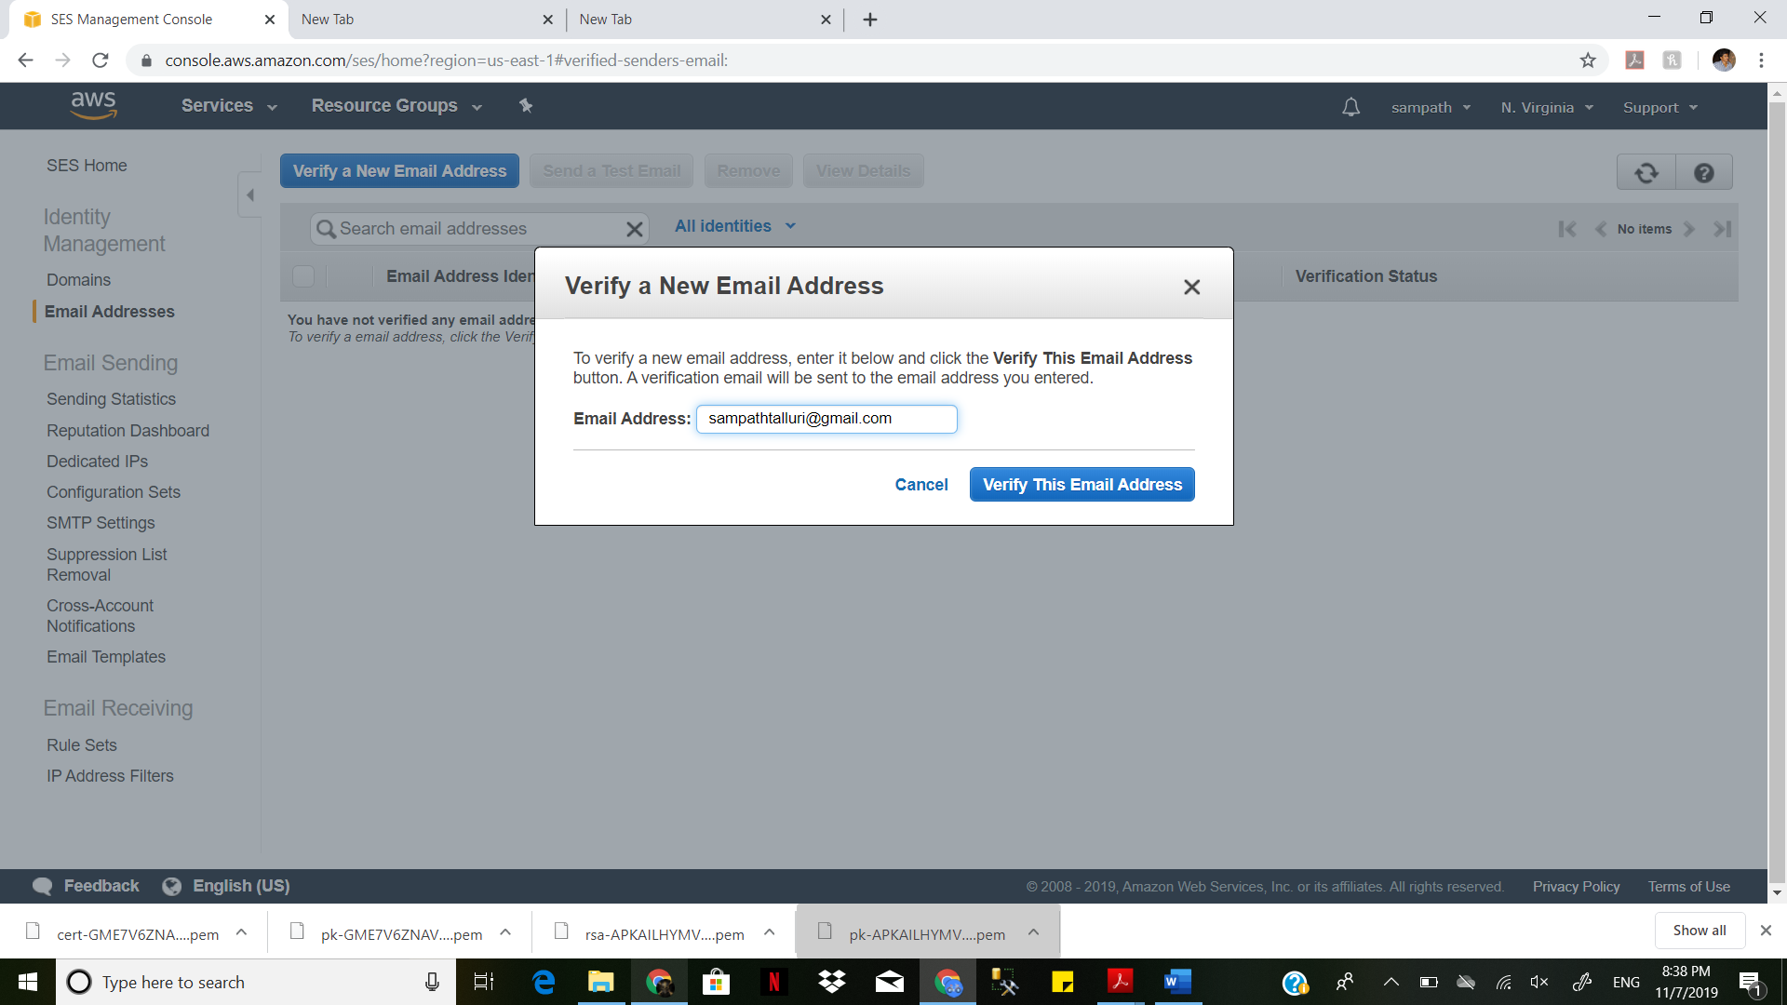

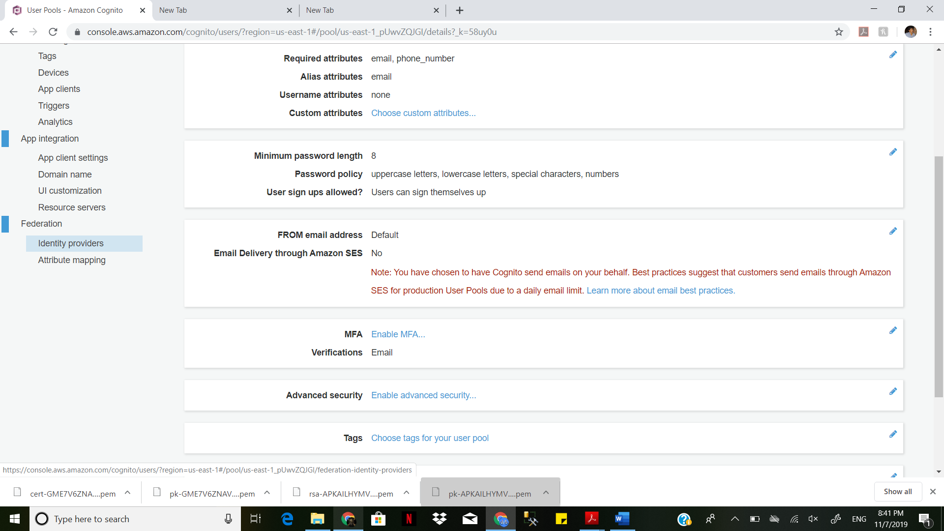

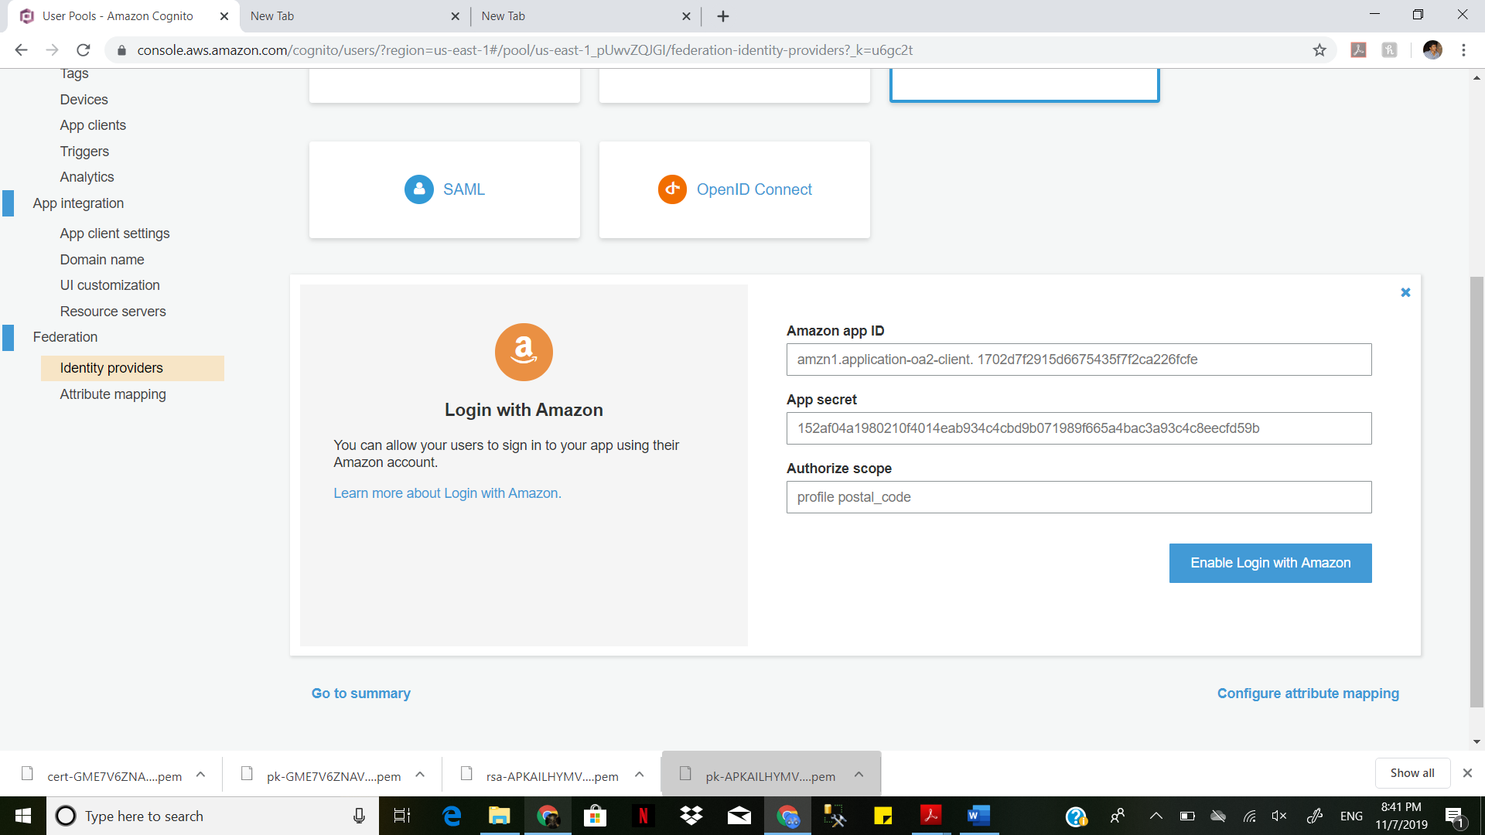

Create an S3 bucket and upload something to it. Describe the security features available. (These can include, but aren't limited to, ACL's, bucket policies, and IAM policies)

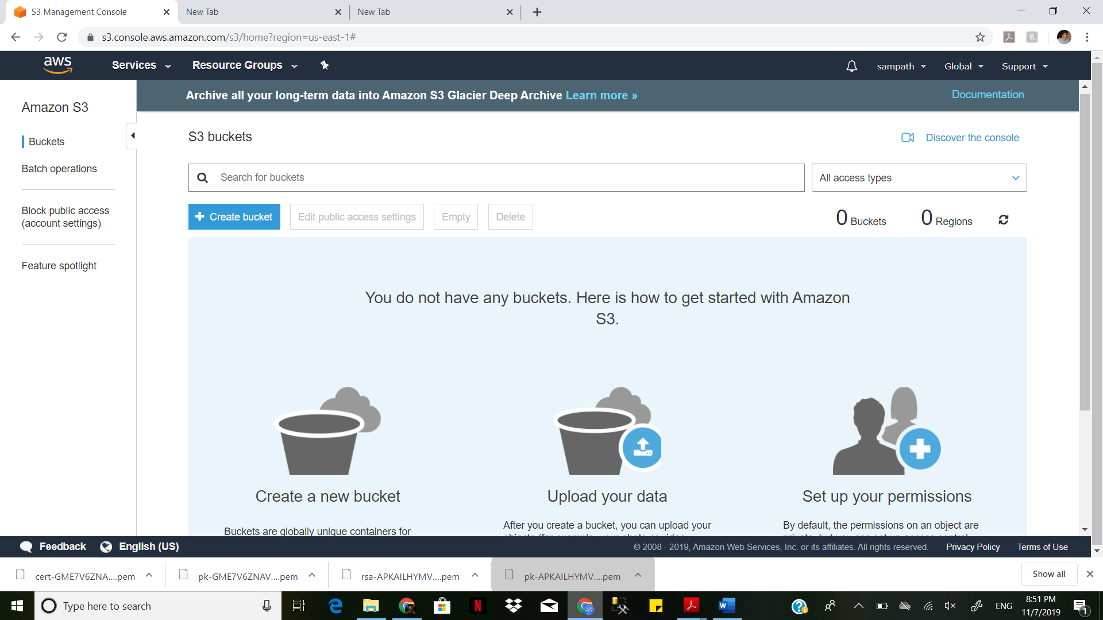

Sign in to the AWS Management Console and open the Amazon S3 console

In the Bucket name list, choose the name of the bucket that you want to set permissions for.

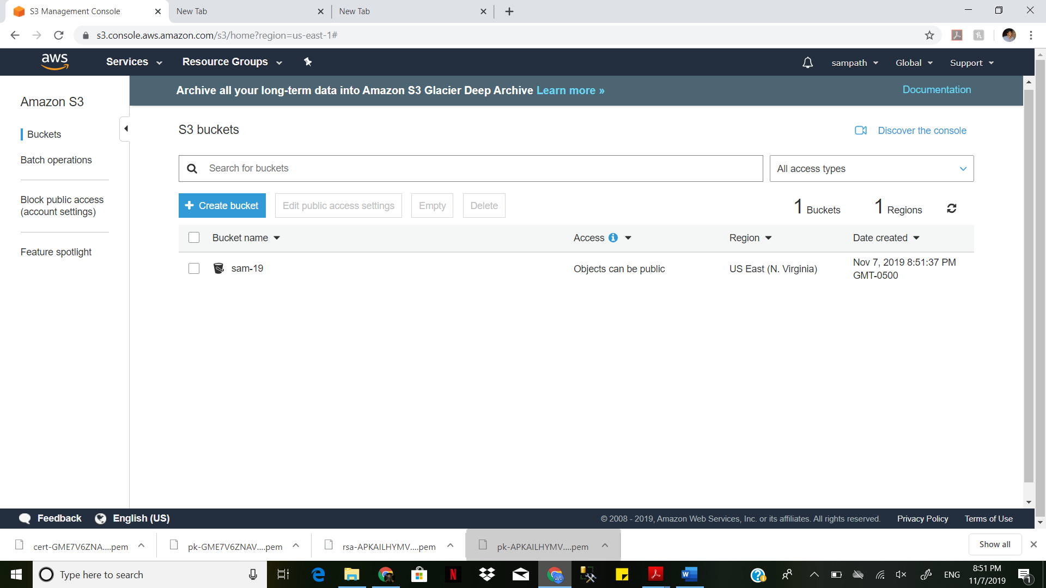

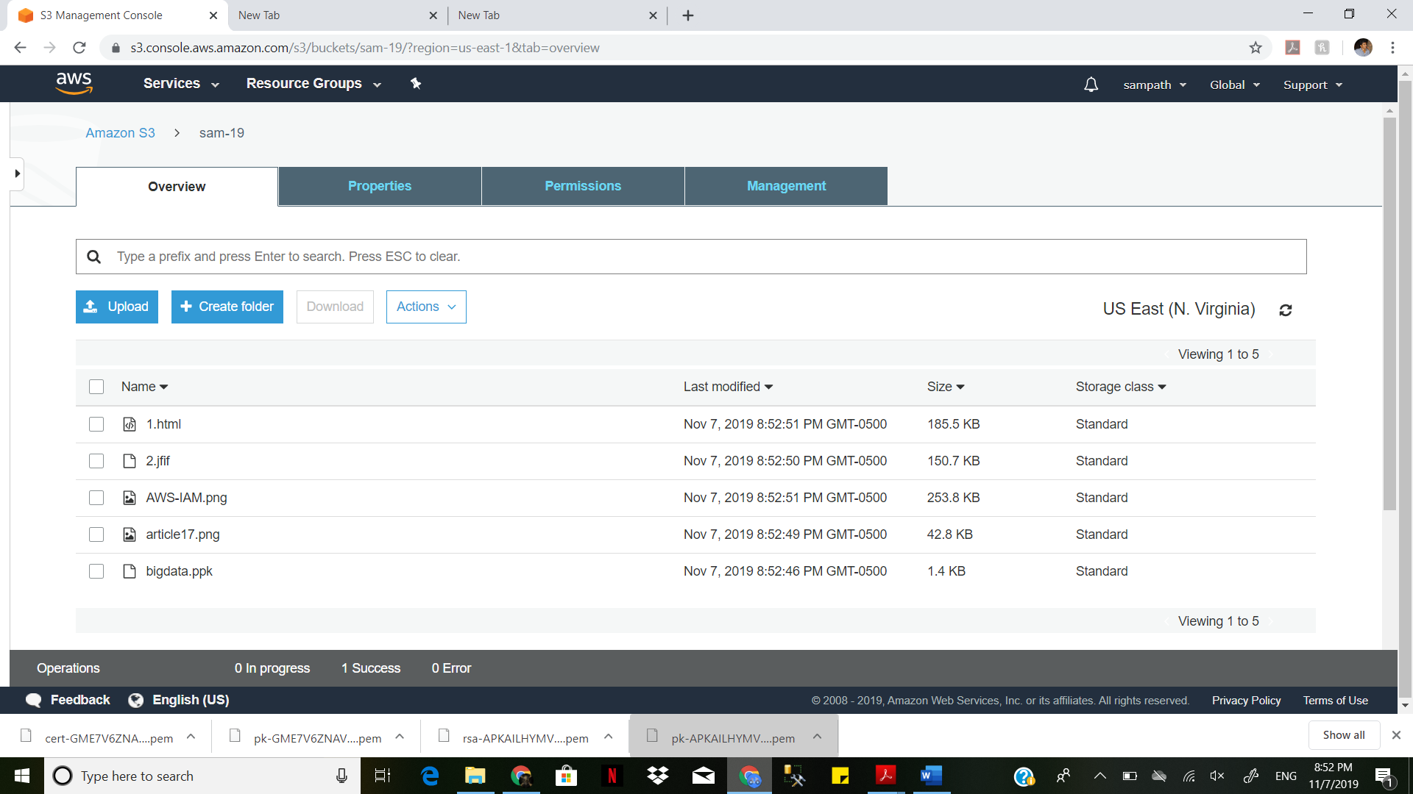

Choose Permissions, and then choose Access Control List.

You can manage bucket access permissions for the following:

Access for your AWS accounted root user

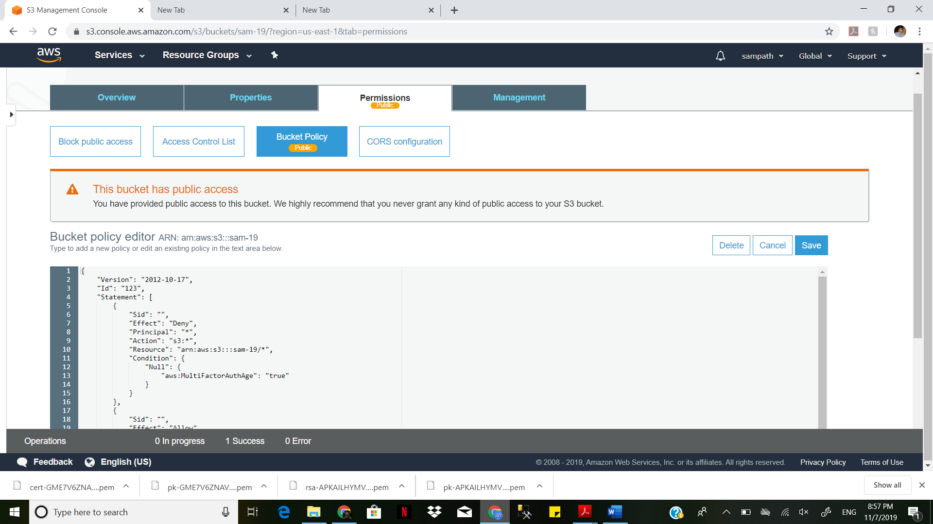

The ownerrefers to the AWS account root user, and not an AWS Identity and Access Management (IAM) user. For more information about the root user, see [The AWS Account Root User](https://docs.aws.amazon.com/IAM/latest/UserGuide/id_root-user.html) in the IAM User Guide.

To change the owner's bucket access permissions, under Access for your AWS accounted root user, choose Your AWS Account (owner).

Select the check boxes for the permissions that you want to change, and then choose Save.

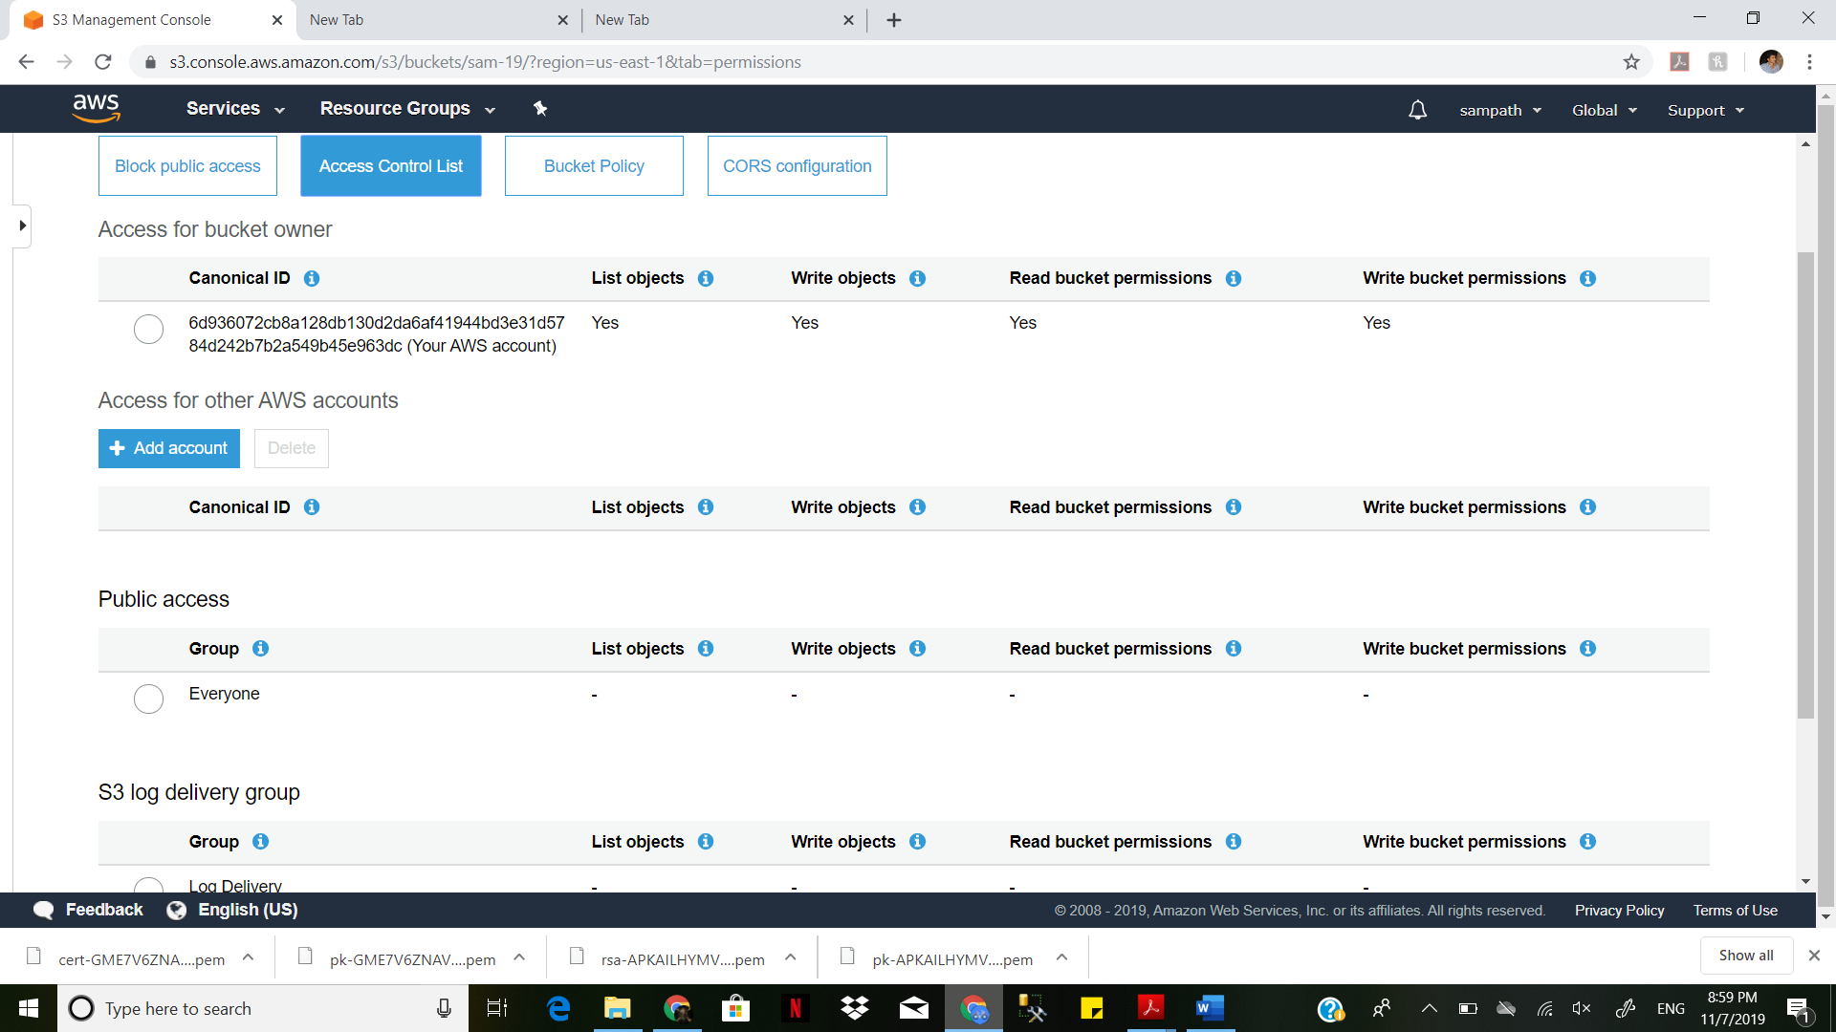

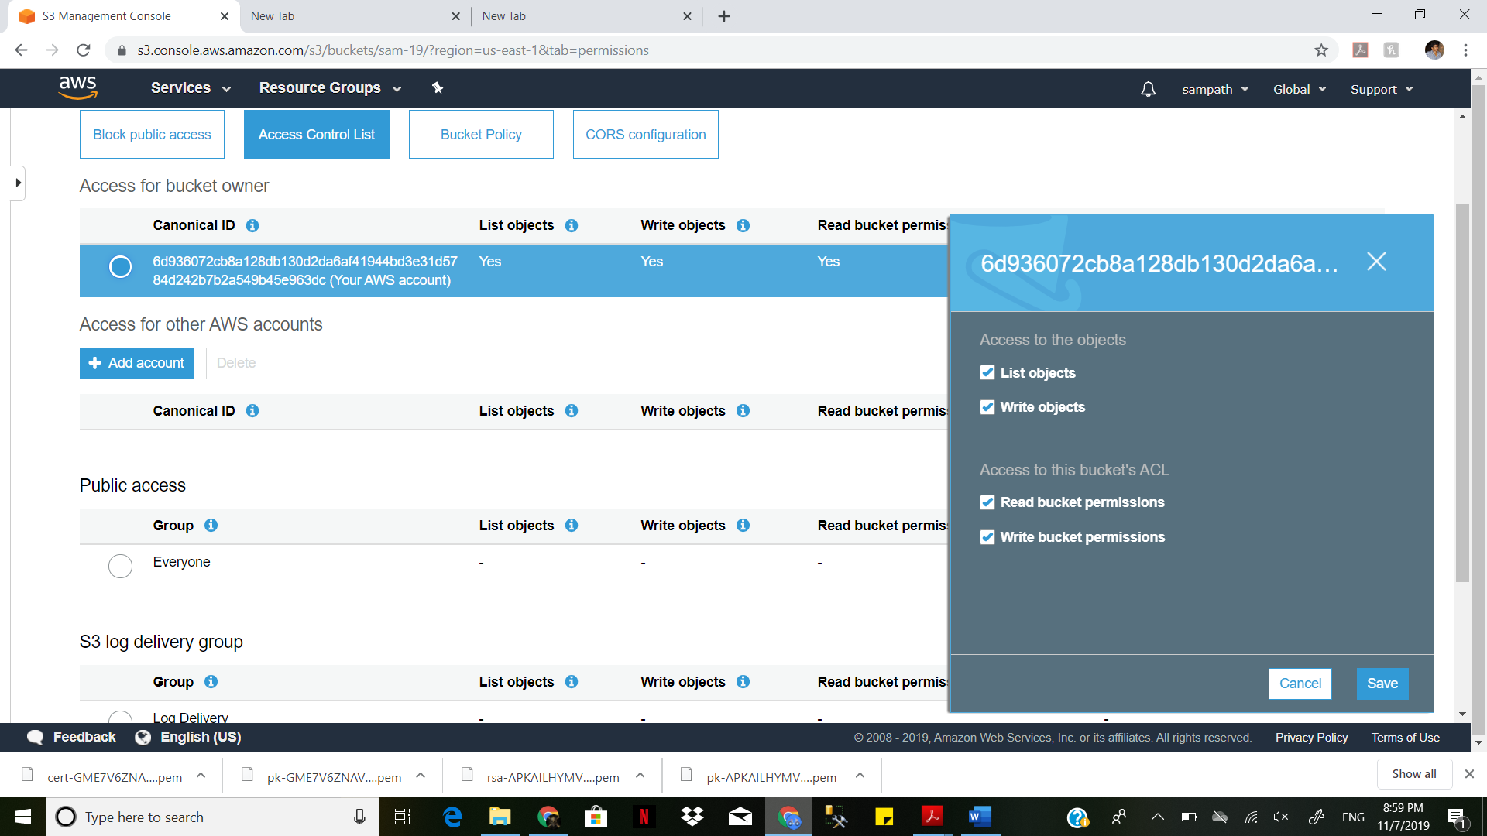

To grant permissions to an AWS user from a different AWS account, under Access for other AWS accounts, choose Add account. In the Enter an ID field, enter the canonical ID of the AWS user that you want to grant bucket permissions to. For information about finding a canonical ID, see [AWS Account Identifiers](https://docs.aws.amazon.com/general/latest/gr/acct-identifiers.html) in the Amazon Web Services General Reference. You can add as many as 99 users.

Select the check boxes next to the permissions that you want to grant to the user, and then choose Save. To display information about the permissions, choose the Help icons.

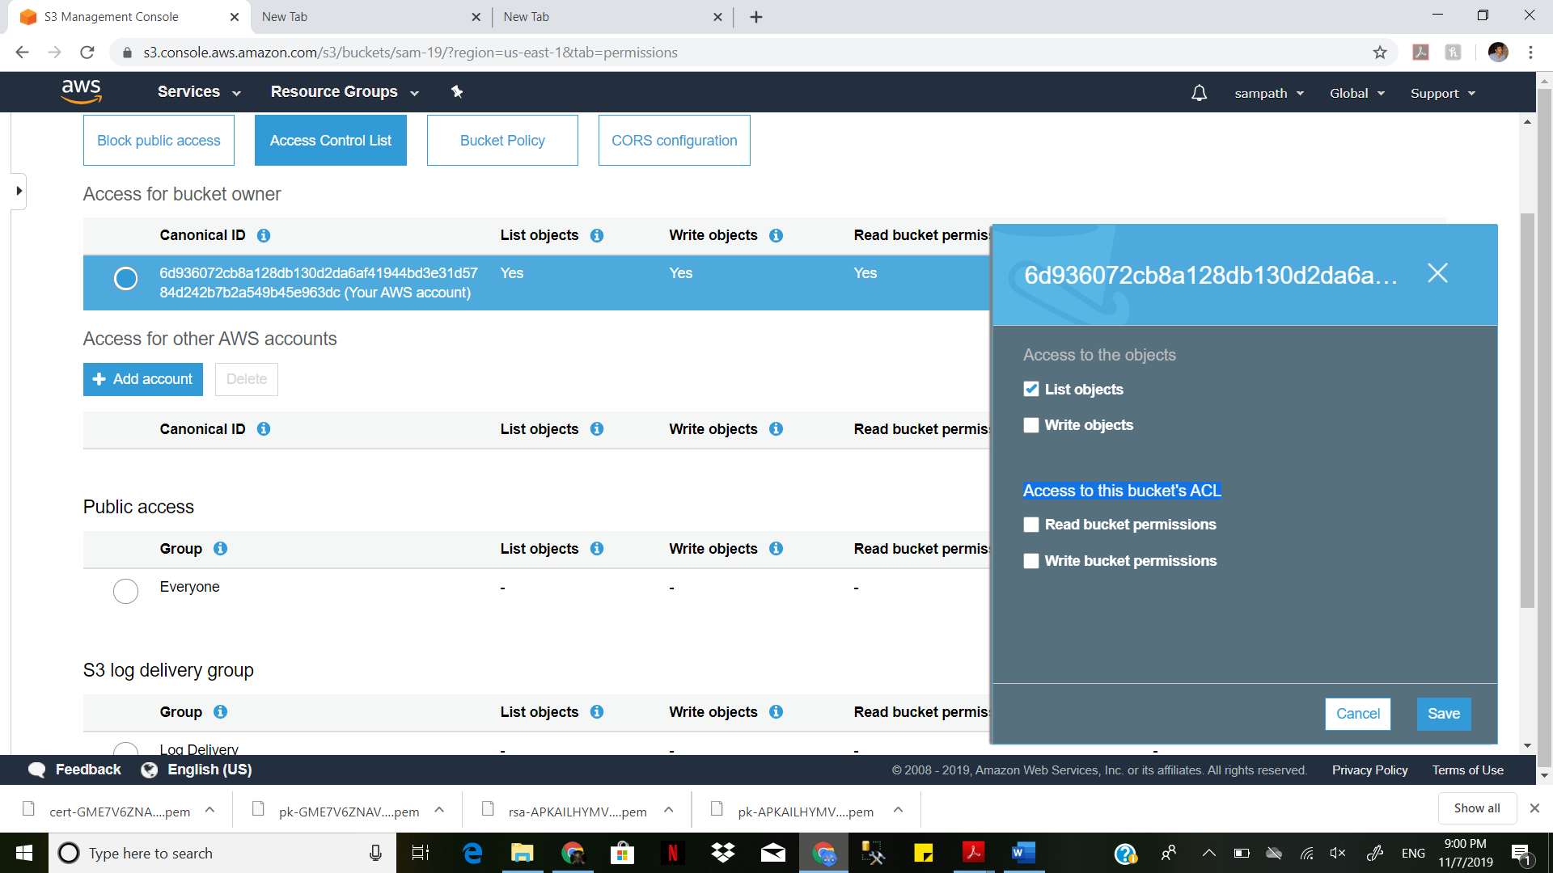

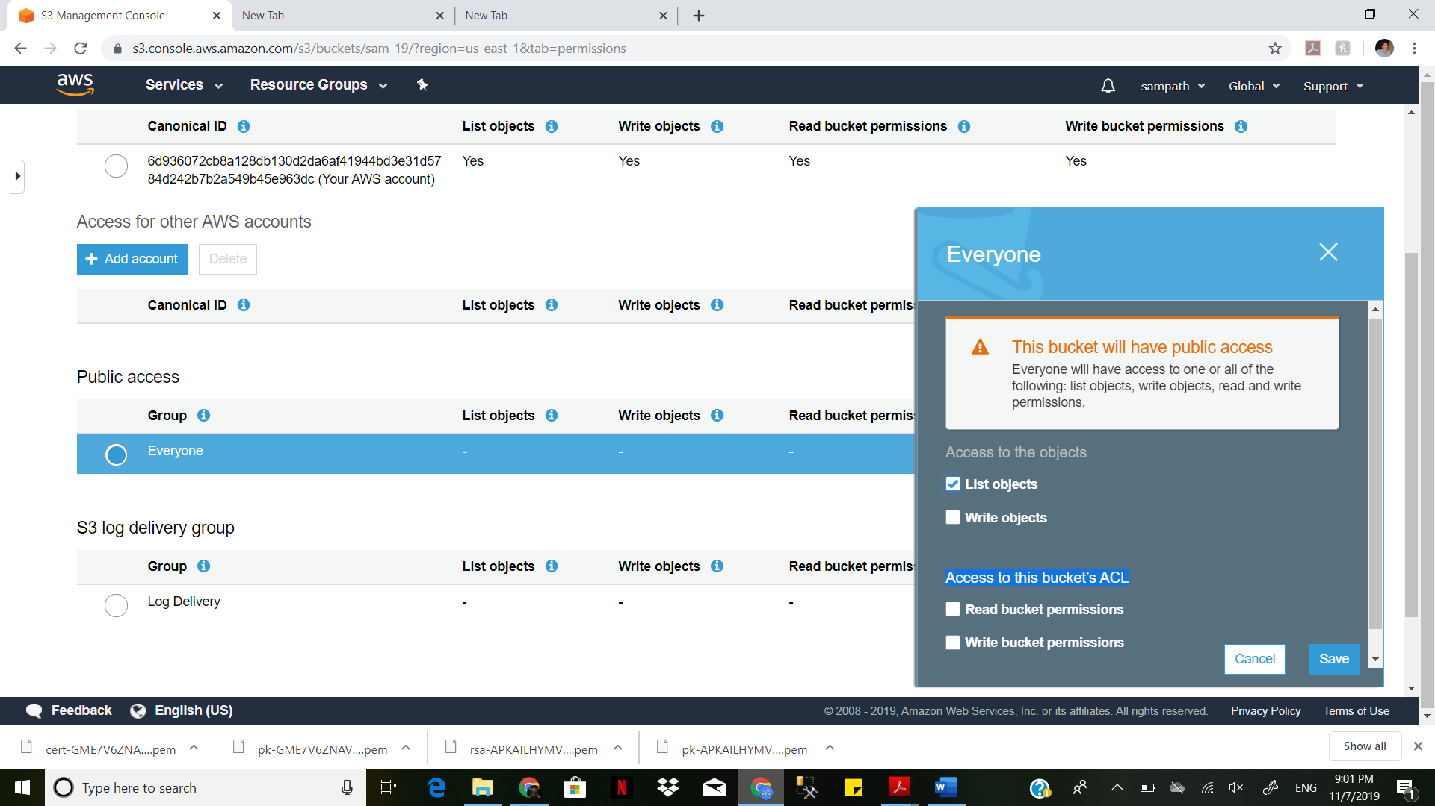

Create a few messages with SQS and discuss security features. (Hint: Make sure to implement server side encryption

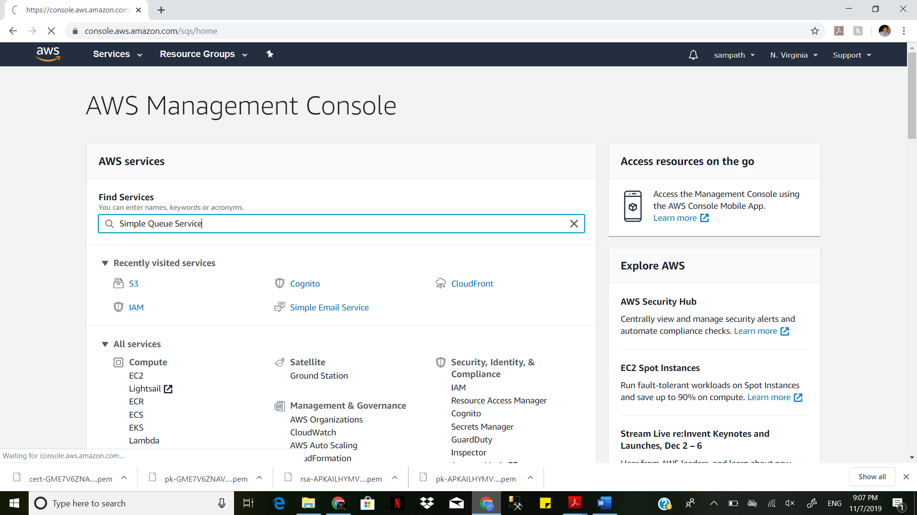

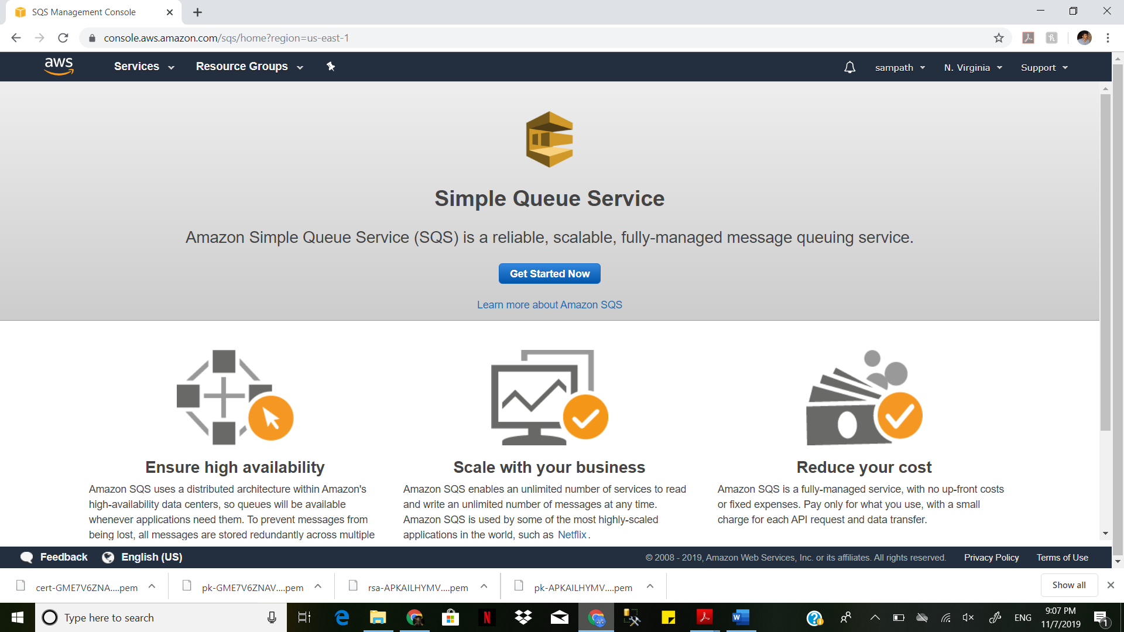

Sign in to the [Amazon SQS console](https://console.aws.amazon.com/sqs/).

Choose Create New Queue.

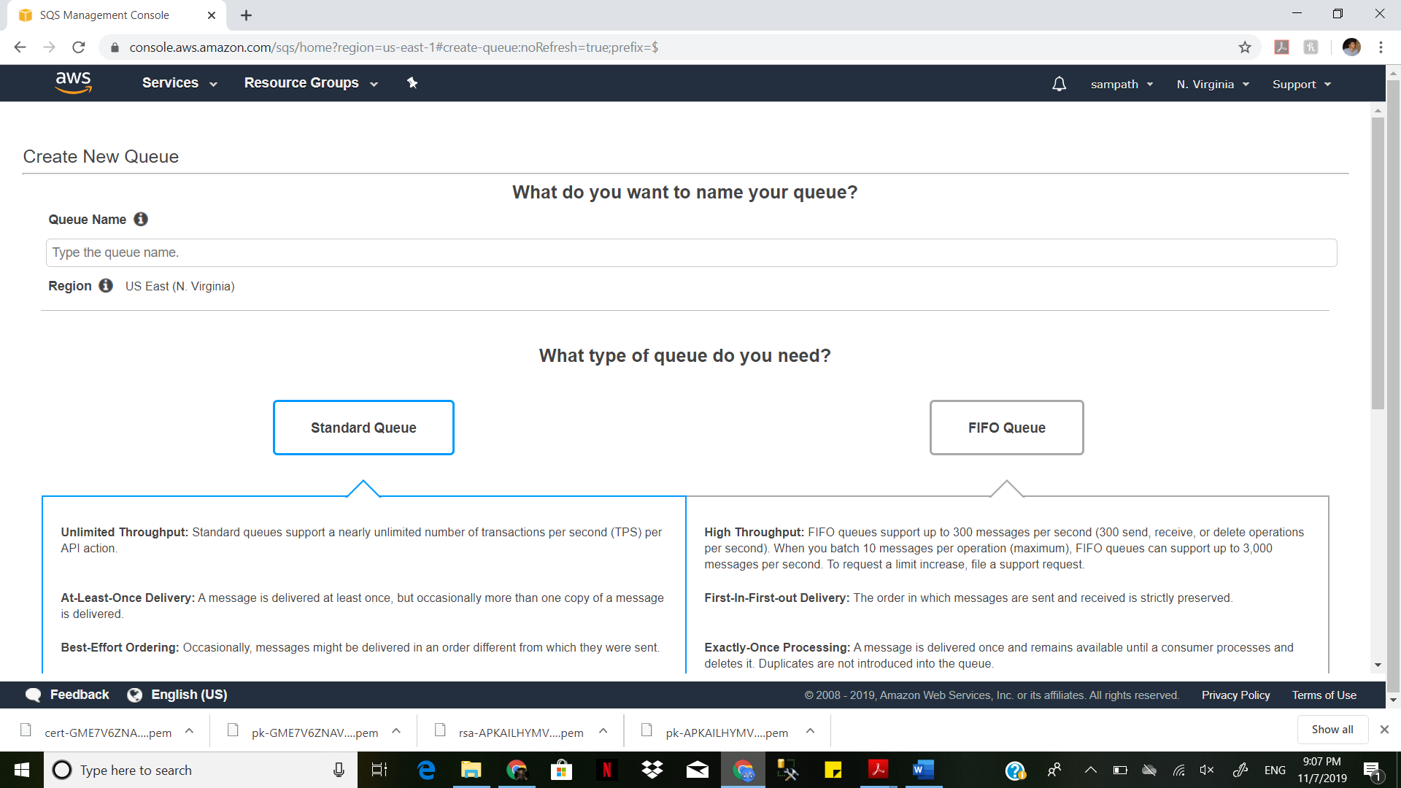

On the Create New Queue page, ensure that you're in the correct region and then type the Queue Name.

Note

The name of a FIFO queue must end with the **sam.fifo** suffix.

Standard is selected by default. Choose FIFO.

Choose Configure Queue, and then choose Use SSE.

Specify the customer master key (CMK) ID. For more information

Optional) For Data key reuse period, specify a value between 1 minute and 24 hours. The default is 5 minutes. For more information, see [Understanding the Data Key Reuse Period](https://docs.aws.amazon.com/AWSSimpleQueueService/latest/SQSDeveloperGuide/sqs-server-side-encryption.html#sqs-how-does-the-data-key-reuse-period-work).

Choose Create Queue.

Your new queue is created with SSE. The encryption status, alias of the CMK, Description, Account, Key ARN, and the Data Key Reuse Period are displayed on the Encryption tab.

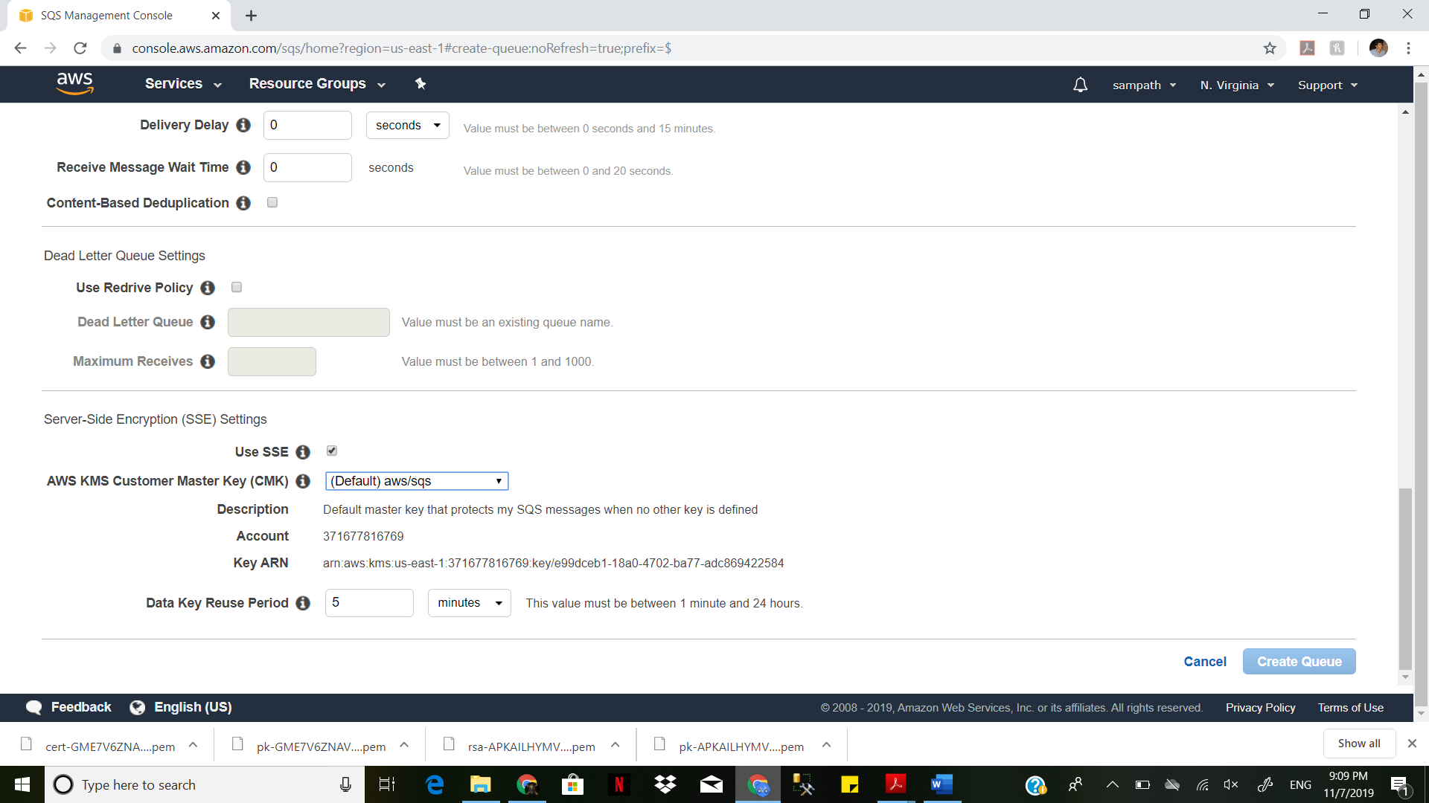

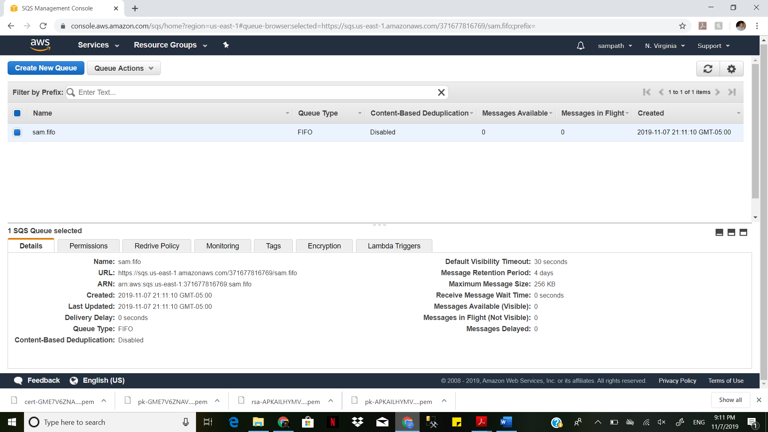

You can use SSE, you must configure AWS KMS key policies to allow encryption of queues and encryption and decryption of messages. For more information, see [Configuring AWS KMS Permissions](https://docs.aws.amazon.com/AWSSimpleQueueService/latest/SQSDeveloperGuide/sqs-server-side-encryption.html#sqs-what-permissions-for-sse)

1. Obtain the customer master key (CMK) ID. For more information, see [Key Terms](https://docs.aws.amazon.com/AWSSimpleQueueService/latest/SQSDeveloperGuide/sqs-server-side-encryption.html#sqs-sse-key-terms).

Note

Keep the following in mind:

* + If you don't specify a custom CMK, Amazon SQS uses the AWS managed CMK for Amazon SQS. For instructions on creating custom CMKs, see [Creating Keys](https://docs.aws.amazon.com/kms/latest/developerguide/create-keys.html) in the AWS Key Management Service Developer Guide.
  + The first time you use the AWS Management Console to specify the AWS managed CMK for Amazon SQS for a queue, AWS KMS creates the AWS managed CMK for Amazon SQS.
  + Alternatively, the first time you use the SendMessage or SendMessageBatch action on a queue with SSE enabled, AWS KMS creates the AWS managed CMK for Amazon SQS.

1. To enable server-side encryption, specify the CMK ID by setting the KmsMasterKeyId attribute of the [CreateQueue](https://docs.aws.amazon.com/AWSSimpleQueueService/latest/APIReference/API_CreateQueue.html) or [SetQueueAttributes](https://docs.aws.amazon.com/AWSSimpleQueueService/latest/APIReference/API_SetQueueAttributes.html) action.

The following code example creates a new queue with SSE using the AWS managed CMK for Amazon SQS:

final AmazonSQS sqs = AmazonSQSClientBuilder.defaultClient();

final Map<String, String> attributes = new HashMap<String, String>();

final CreateQueueRequest createRequest = new CreateQueueRequest("MyQueue").withAttributes(attributes);

*// Enable server-side encryption by specifying the alias ARN of the*

*// AWS managed CMK for Amazon SQS.*

final String kmsMasterKeyAlias = "arn:aws:kms:us-east-2:123456789012:alias/aws/sqs";

attributes.put("KmsMasterKeyId", kmsMasterKeyAlias);

*// (Optional) Specify the length of time, in seconds, for which Amazon SQS can reuse*

attributes.put("KmsDataKeyReusePeriodSeconds", "60");

final CreateQueueResult createResult = client.createQueue(createRequest);

The following code example creates a new queue with SSE using a custom CMK:

final AmazonSQS sqs = AmazonSQSClientBuilder.defaultClient();

final Map<String, String> attributes = new HashMap<String, String>();

final CreateQueueRequest createRequest = new CreateQueueRequest("MyQueue").withAttributes(attributes);

*// Enable server-side encryption by specifying the alias ARN of the custom CMK.*

final String kmsMasterKeyAlias = "arn:aws:kms:us-east-2:123456789012:alias/MyAlias";

attributes.put("KmsMasterKeyId", kmsMasterKeyAlias);

*// (Optional) Specify the length of time, in seconds, for which Amazon SQS can reuse*

*// a data key to encrypt or decrypt messages before calling AWS KMS again.*

attributes.put("KmsDataKeyReusePeriodSeconds", "864000");

final CreateQueueResult createResult = client.createQueue(createRequest);

1. (Optional) Specify the length of time, in seconds, for which Amazon SQS can [reuse a data key](https://docs.aws.amazon.com/AWSSimpleQueueService/latest/SQSDeveloperGuide/sqs-server-side-encryption.html#sqs-sse-key-terms) to encrypt or decrypt messages before calling AWS KMS again. Set the KmsDataKeyReusePeriodSeconds attribute of the [CreateQueue](https://docs.aws.amazon.com/AWSSimpleQueueService/latest/APIReference/API_CreateQueue.html) or [SetQueueAttributes](https://docs.aws.amazon.com/AWSSimpleQueueService/latest/APIReference/API_SetQueueAttributes.html) action. Possible values may be between 60 seconds (1 minute) and 86,400 seconds (24 hours). If you don't specify a value, the default value of 300 seconds (5 minutes) is used.

The first code example above sets the data key reuse time period to 60 seconds (1 minute). The second code example sets it to 86,400 seconds (24 hours). The following code example sets the data key reuse period to 60 seconds (1 minute):

*// (Optional) Specify the length of time, in seconds, for which Amazon SQS can reuse*

*// a data key to encrypt or decrypt messages before calling AWS KMS again.*

attributes.put("KmsDataKeyReusePeriodSeconds", "60");

For information about retrieving the attributes of a queue, see [Examples](https://docs.aws.amazon.com/AWSSimpleQueueService/latest/APIReference/API_GetQueueAttributes.html#API_GetQueueAttributes_Examples) in the Amazon Simple Queue Service API Reference.

To retrieve the CMK ID or the data key reuse period for a particular queue, use the KmsMasterKeyId and KmsDataKeyReusePeriodSeconds attributes of the [GetQueueAttributes](https://docs.aws.amazon.com/AWSSimpleQueueService/latest/APIReference/API_GetQueueAttributes.html) action.

Reference:

<https://docs.aws.amazon.com/AWSSimpleQueueService/latest/SQSDeveloperGuide/sqs-create-queue-sse.html>

<https://docs.aws.amazon.com/AmazonS3/latest/user-guide/set-bucket-permissions.html>